**BIBD Practicals**

**Practical No 1**

**Aim:** Classification using orange tool.

Step1:- We will be taking the available data files in order to predict the future things so open a new data file and drag the file just over it.

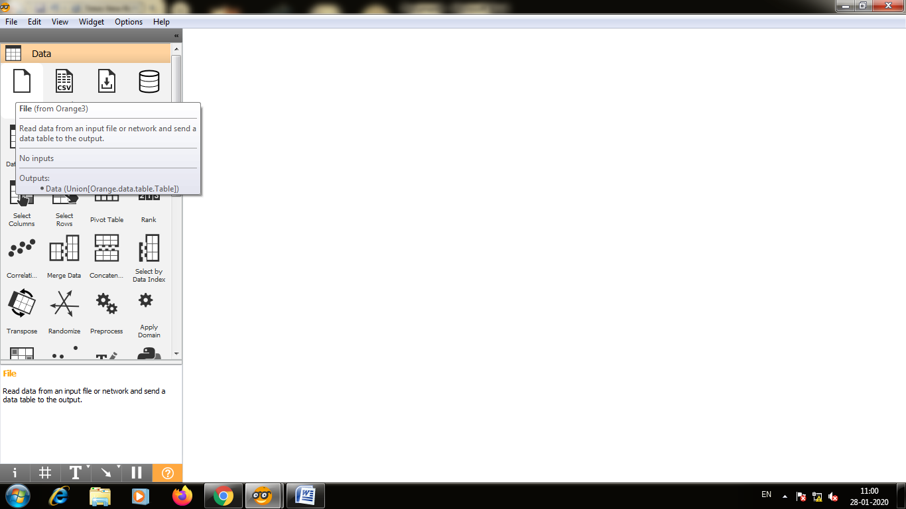

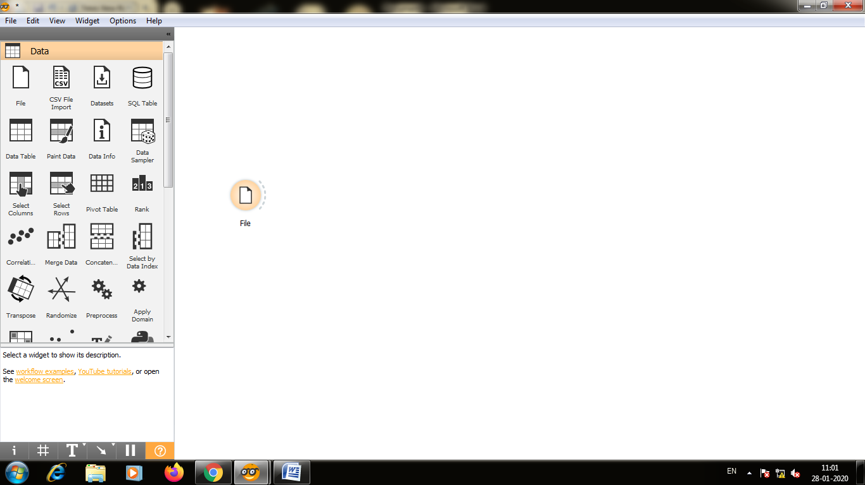

Step2:-Double click on the data file,from the dropdown list select the zoo.tab data file and close it.

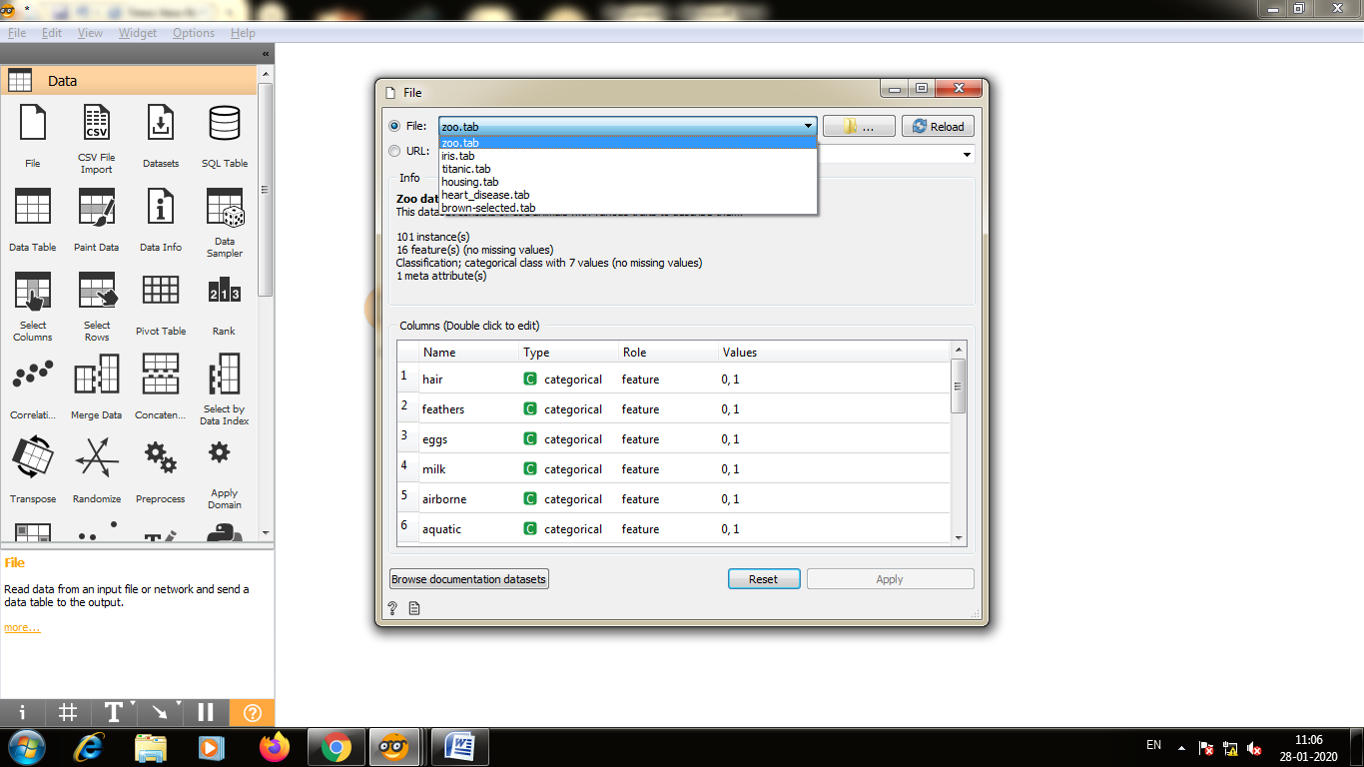

Step3:-Select the file and type data sampler.

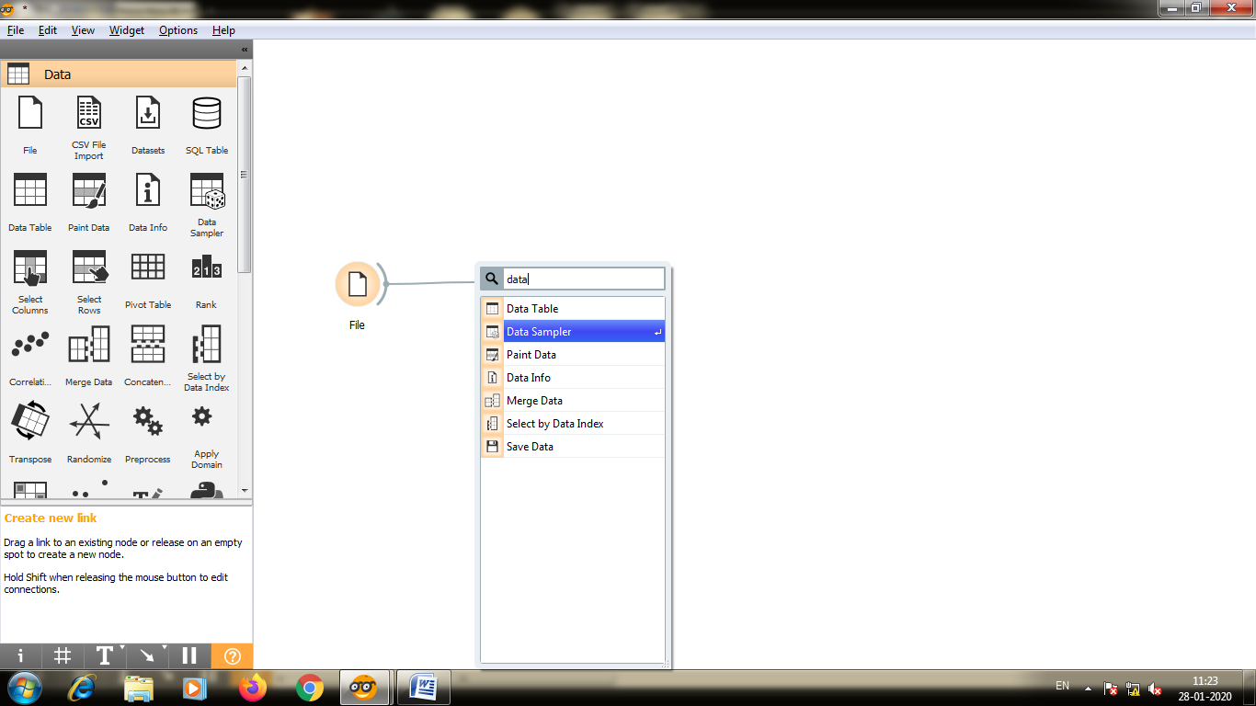

Step4:-Whenever we do prediction we will need to connect them with native bayes and classification tree to the prediction by dragging them across.

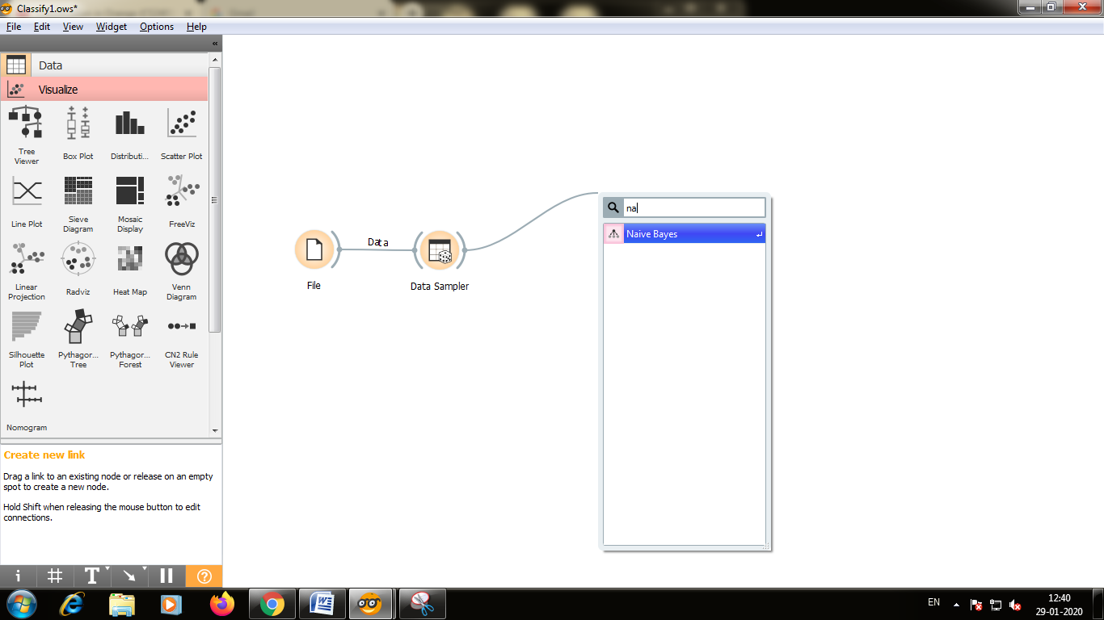

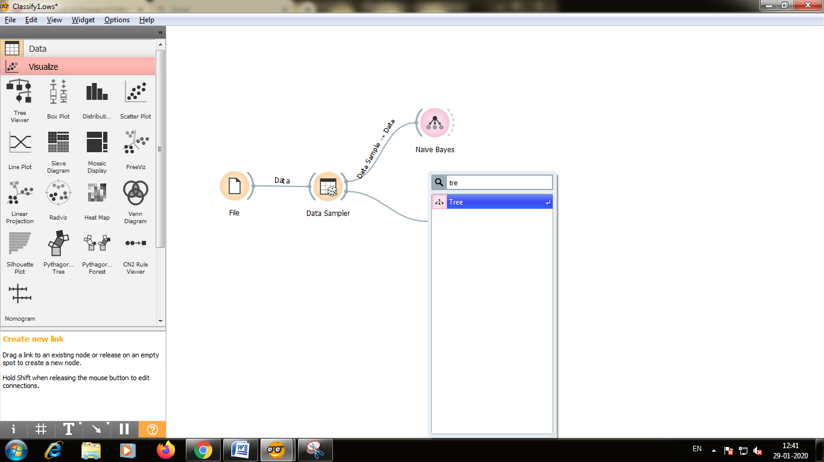

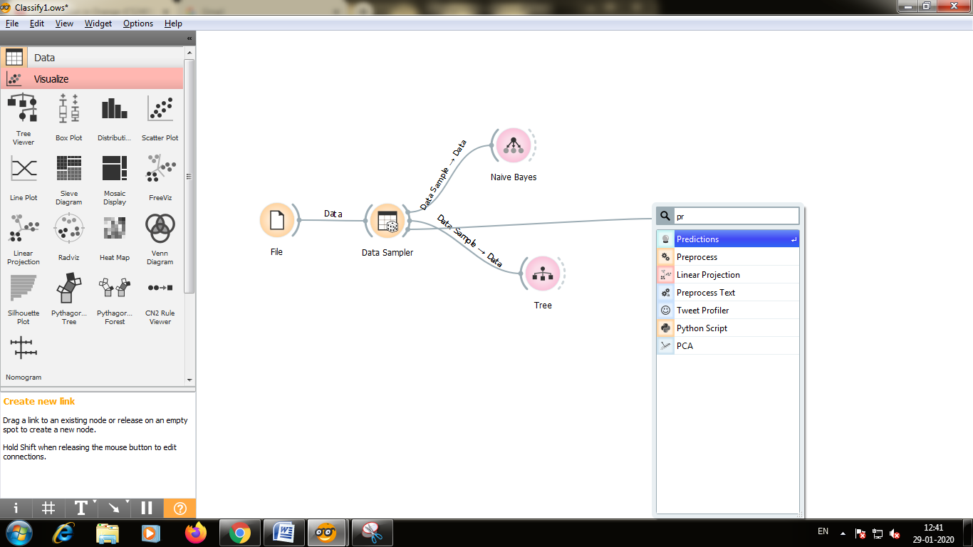

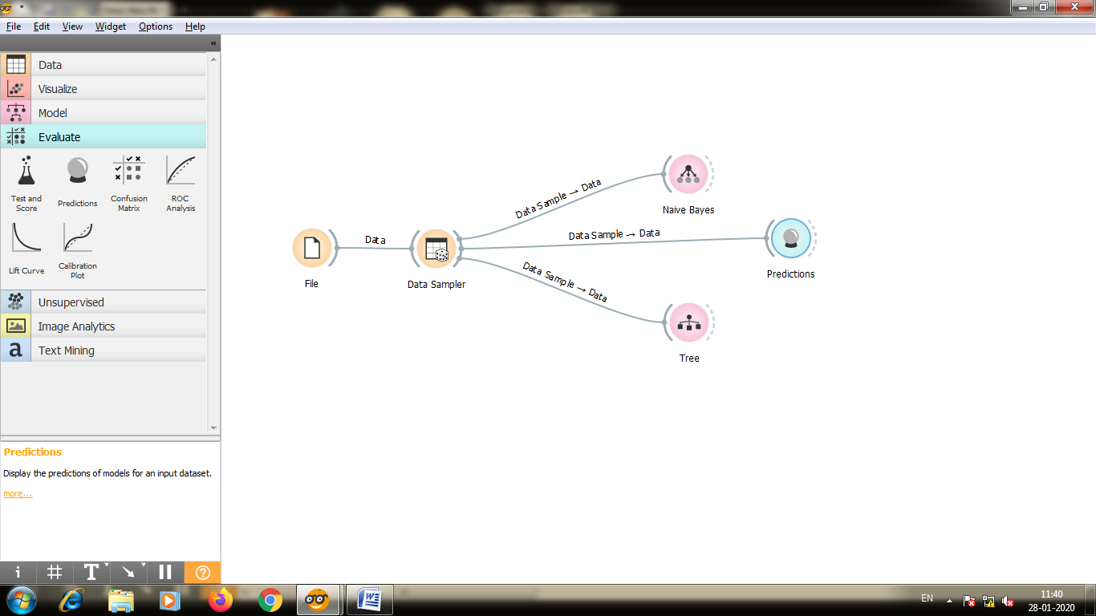

Step5:-The model is also able to show how you can predict the type class of the various attributes so you can use the nomogram for that double click on nomogram and you see the type of target class list so let’s see if the you want to see if the data input you can drag these points across by sliding across the data one means yes and zero means no

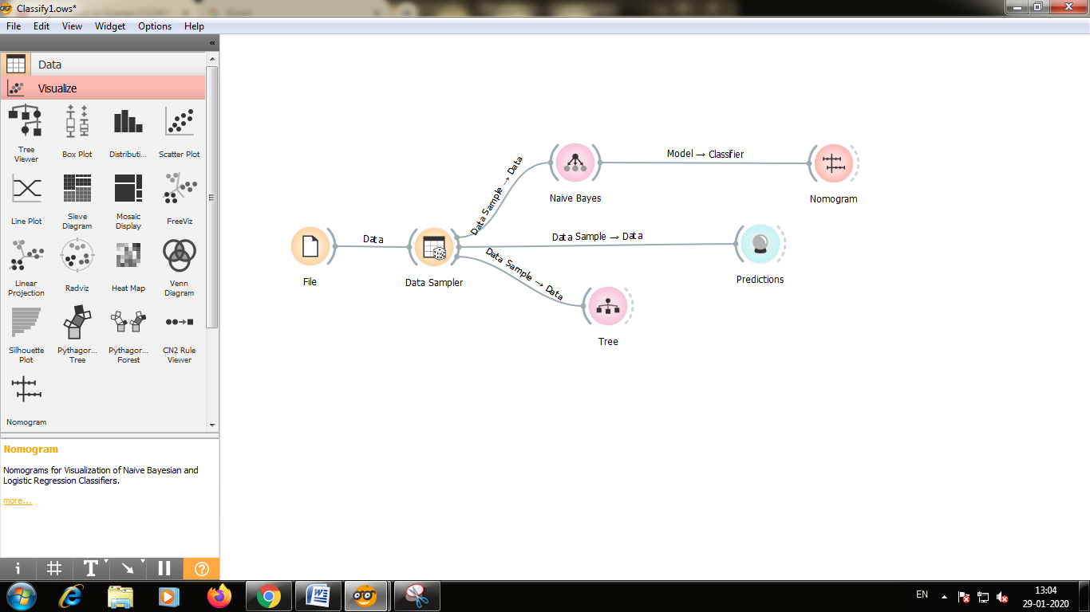

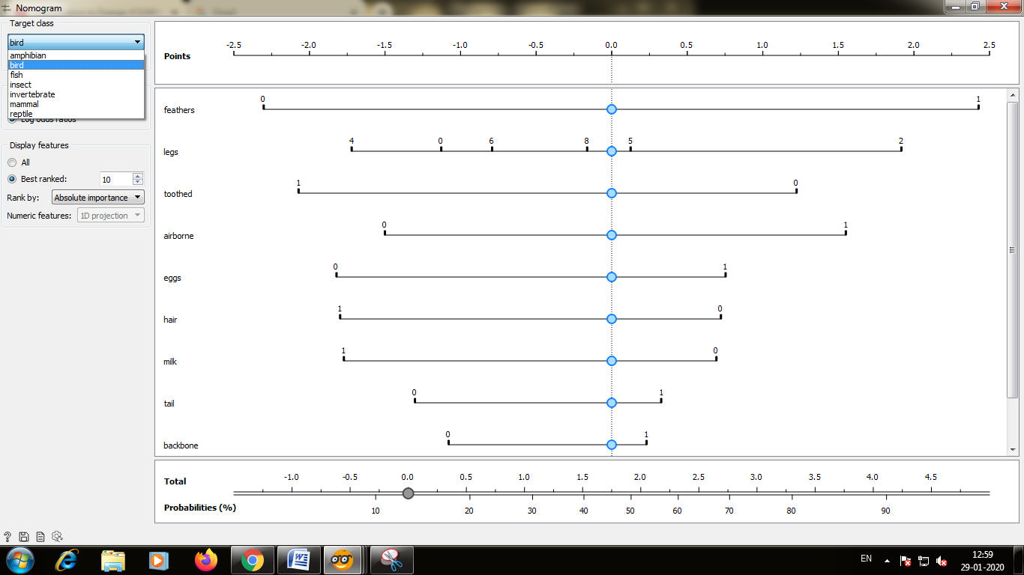

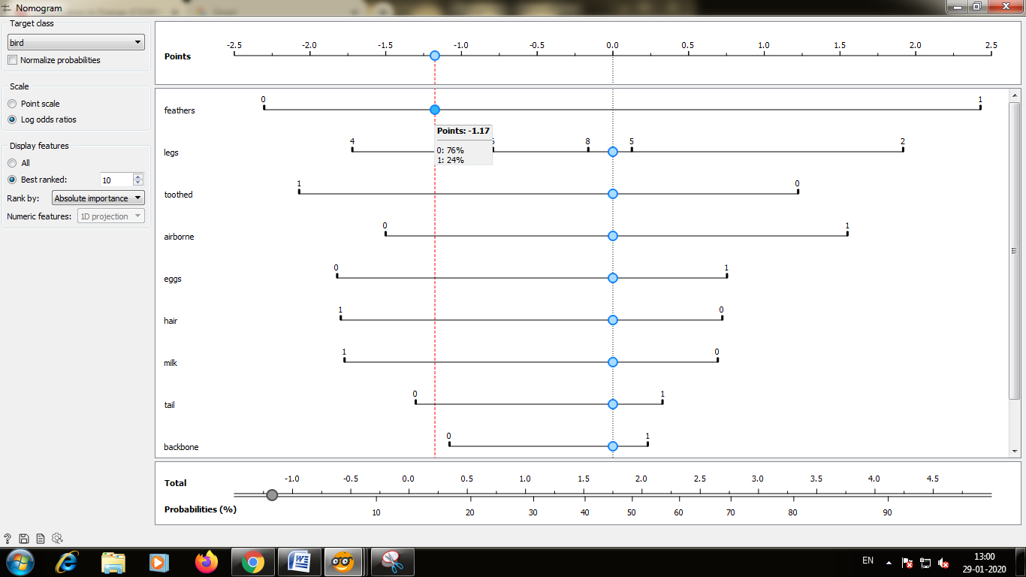

Step6:-Connect the Native Bayes and Classification Tree to Prediction

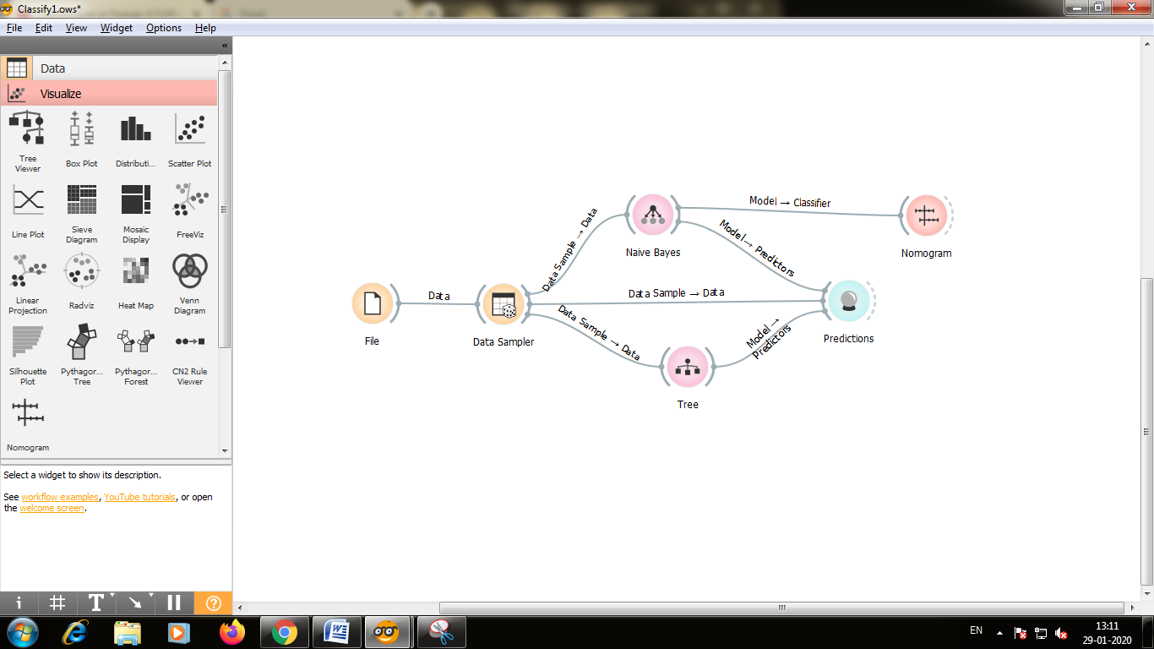

Step7:-Double click on the prediction and you will the data attributes by seeing this input from hair feathers eggs milk and so on.

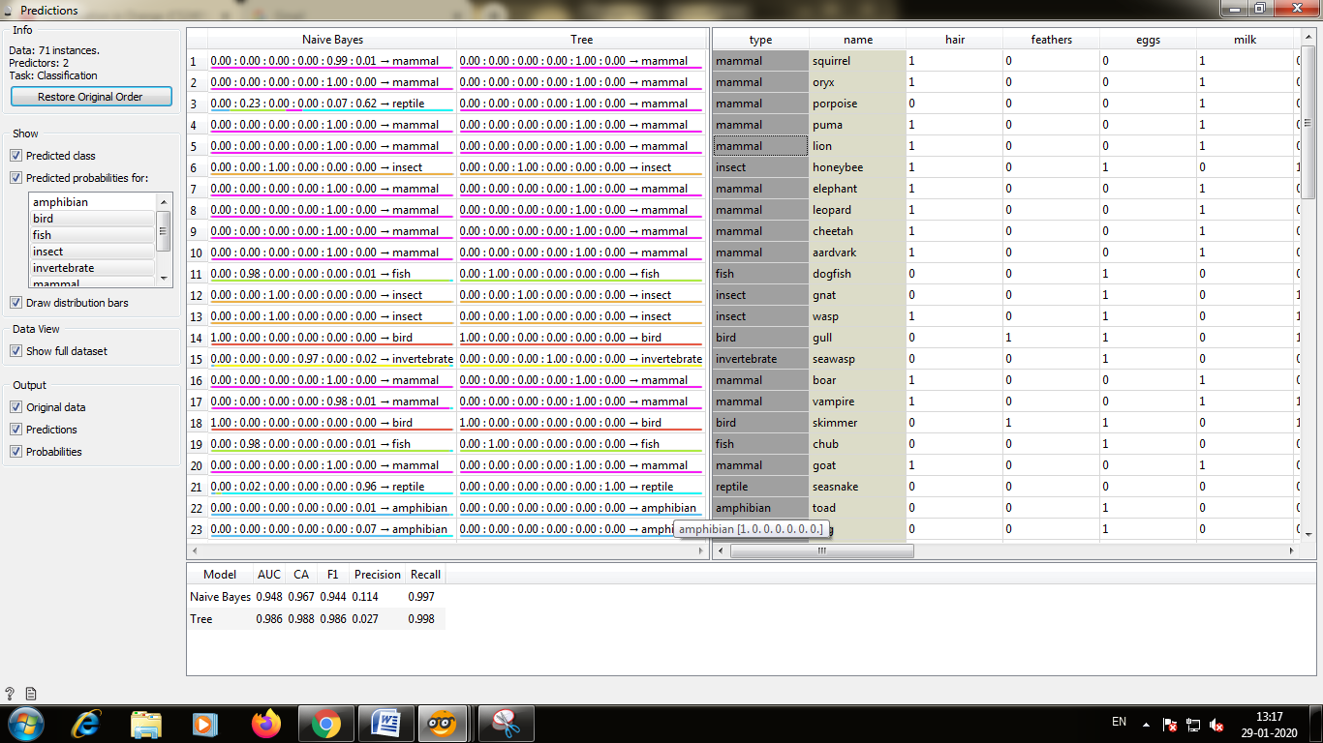

Step8:-There are different ways to visualize the data on the left side of the screen you can scroll down and you will see the visualize step so you click on the tab and you will see several regions that you can use to visualize the data like scatter plot,linear projection etc.

For this example we are going to use linear projection.

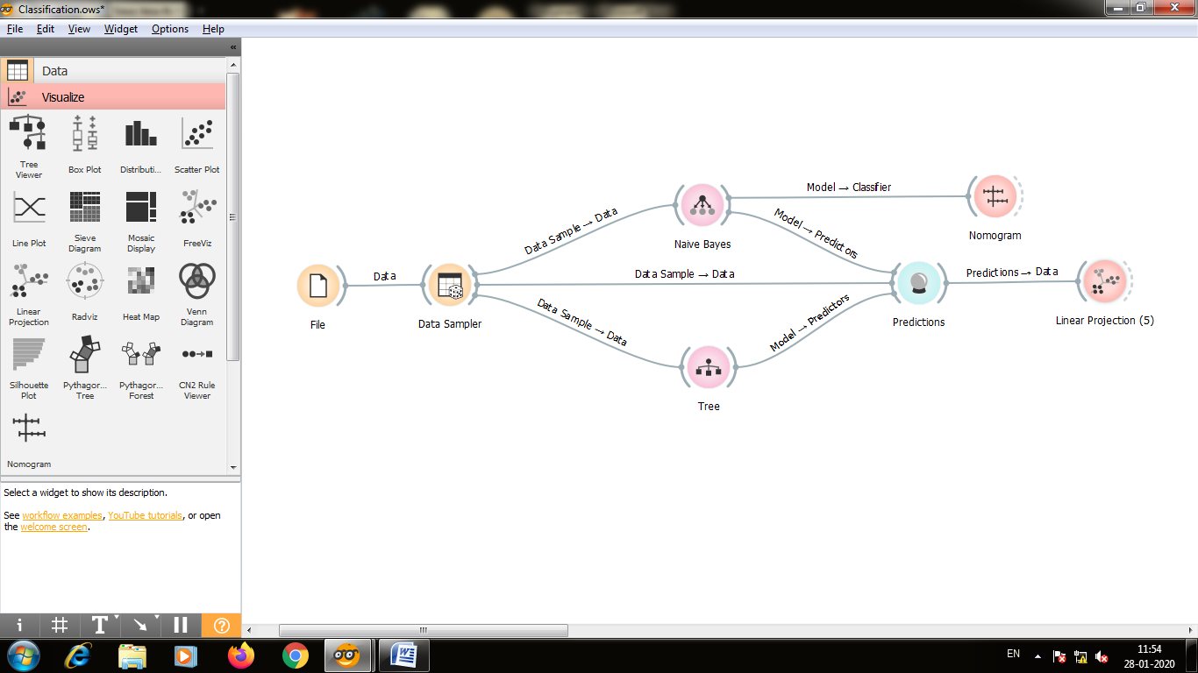Step9:-Double click on the linear projection and you can the different classes of zoo animal.

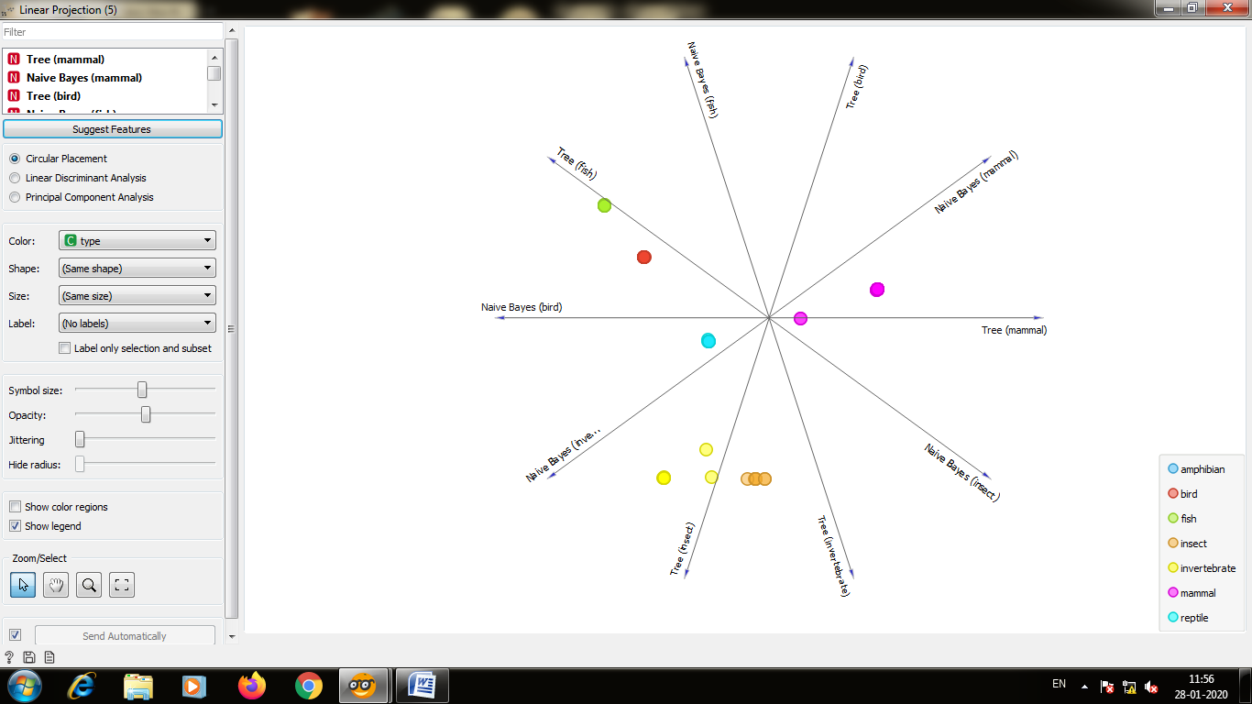

**Practical No.: 2**

**Text Classification**

We are going to classify the data based on text . and for that we are going to use unclassify data and check whether the tale is animal tale or tale of magic.

**Steps for text classification**

1. Take a Corpus and take grimTale.selected and to the corpusViewer.
2. In CorpusViewer take 10 ATU fields to provide data
3. 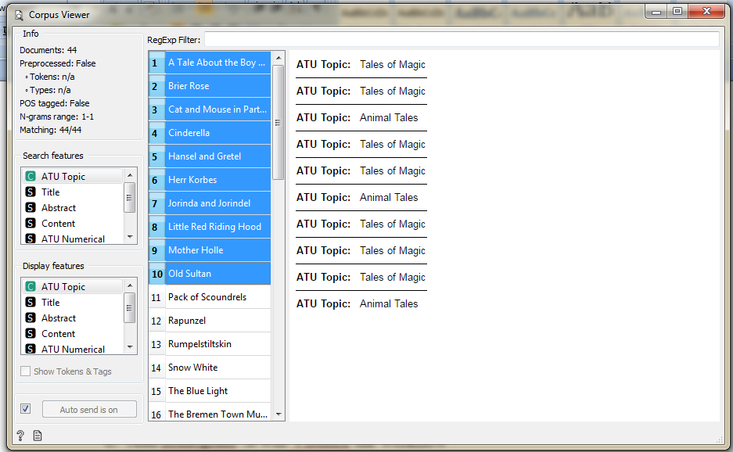
4. And to this add preprocess text for processing the data
5. And connect this to BagOfWords.
6. Take Logistic Regression to bag of words .it construct the model. 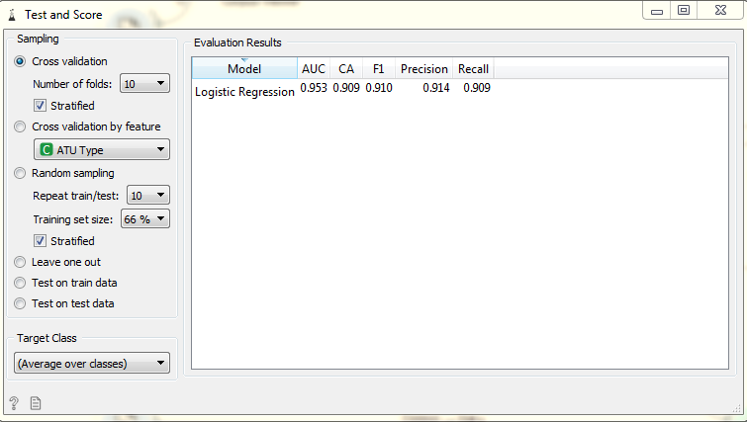
7. Add nomogram .it will Visulize the workflow 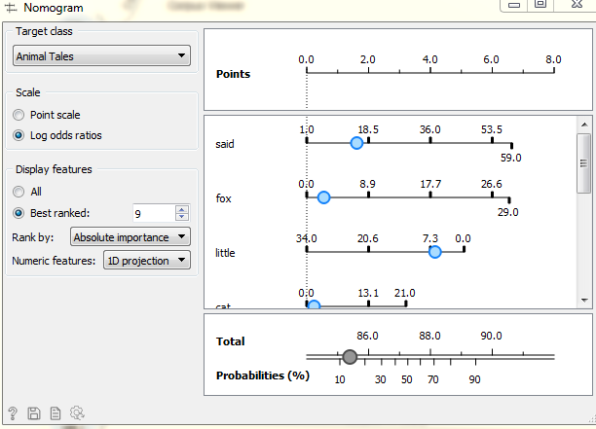
8. Add Test and Score it will cross validate the workflow 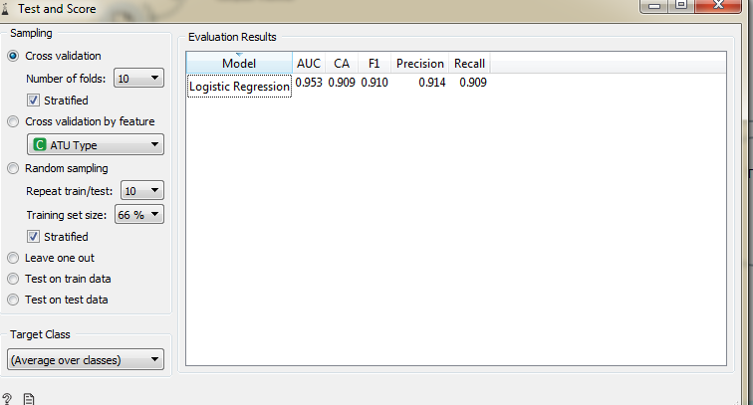
9. and to check our workflow whther it is right or wrong we take another corpus whom we alredy know the classification for that we use Andersen.tab and connect it to prediction 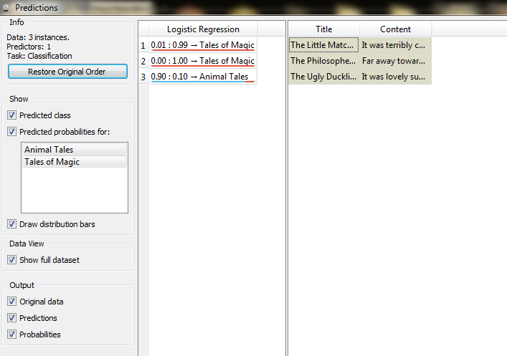
10. and finally our workflow looks like this 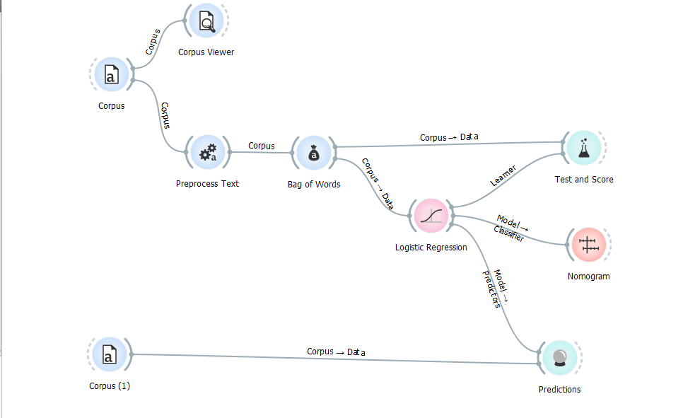

**Practical No.: 3**

**Big Data: Image Analytics-Classification**

Image classification analyzes the numerical properties of various image features and organizes data into categories. Classification algorithms typically employ two phases of processing: training and testing.

**Steps for Image analytics classification:**

1. **Import Images:** The first thing to do is to import the image via the **Import Images** widget. You can think this widget as the **File**widget for image. However, **Import Images** widget accepts a directory instead of a file.

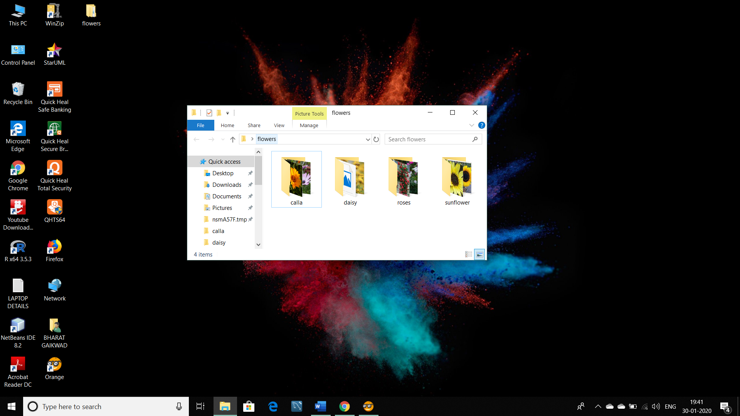

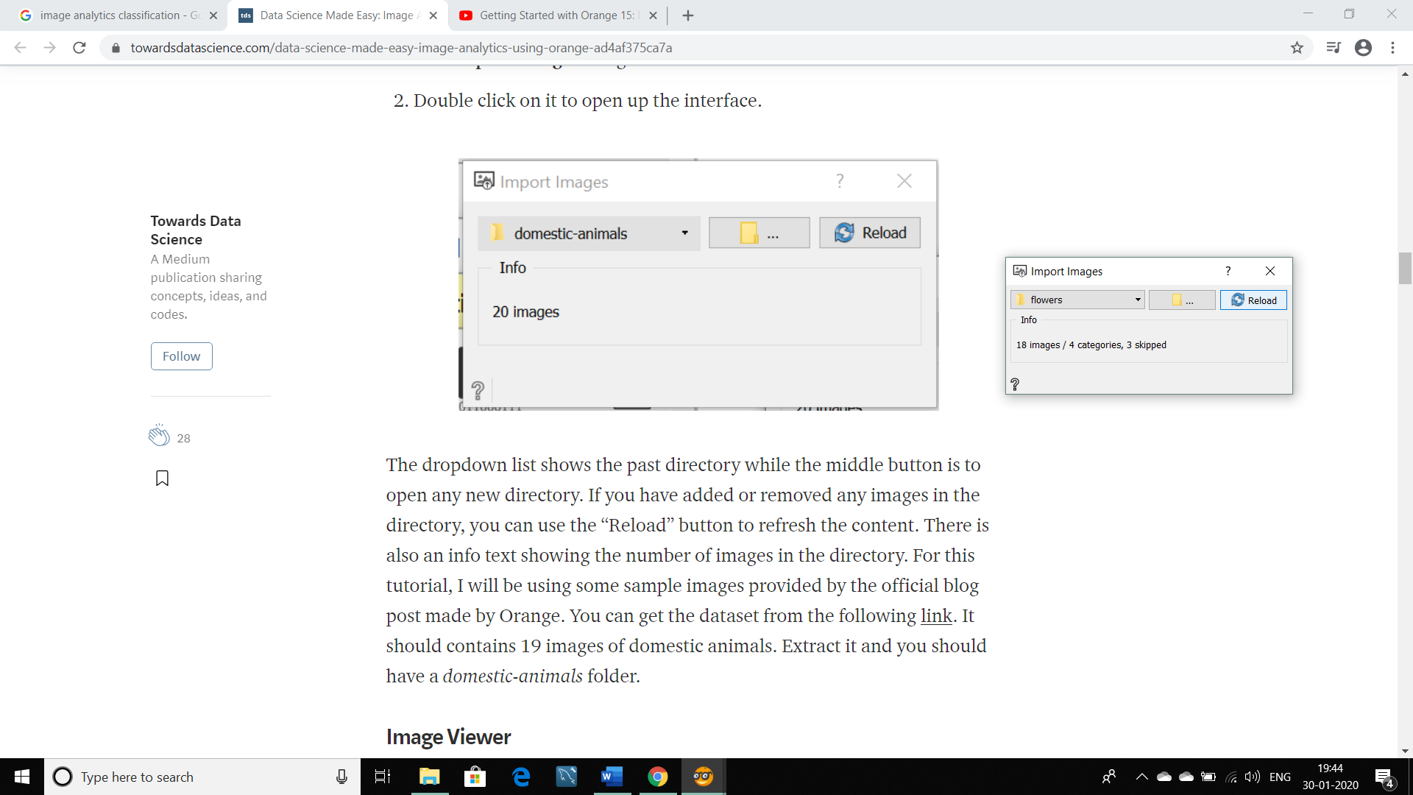

## Image Viewer: Next, we will be relying on the **Image Viewer** widget to check the content of the directory. This widget will display all of the loaded images.

## Connect Image viewer to import images

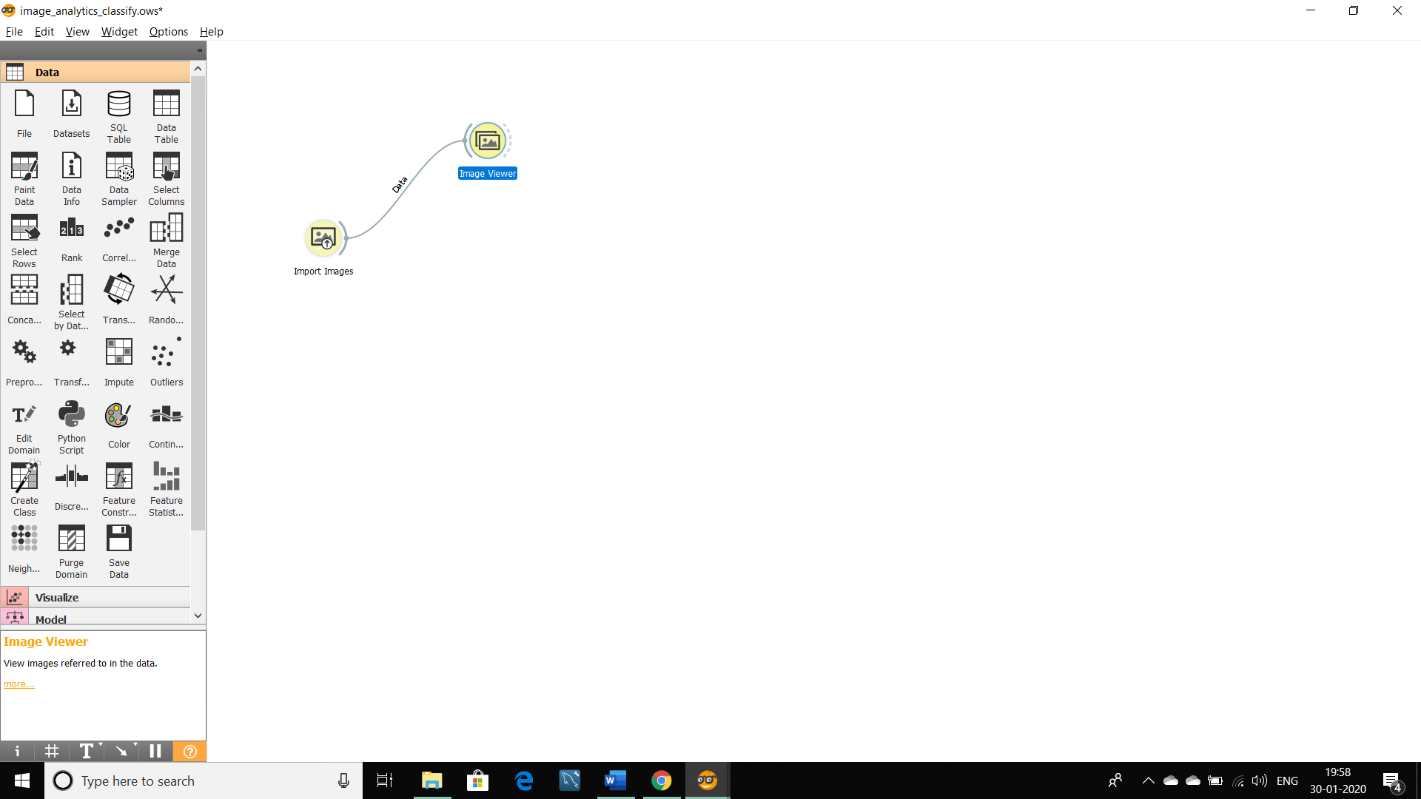

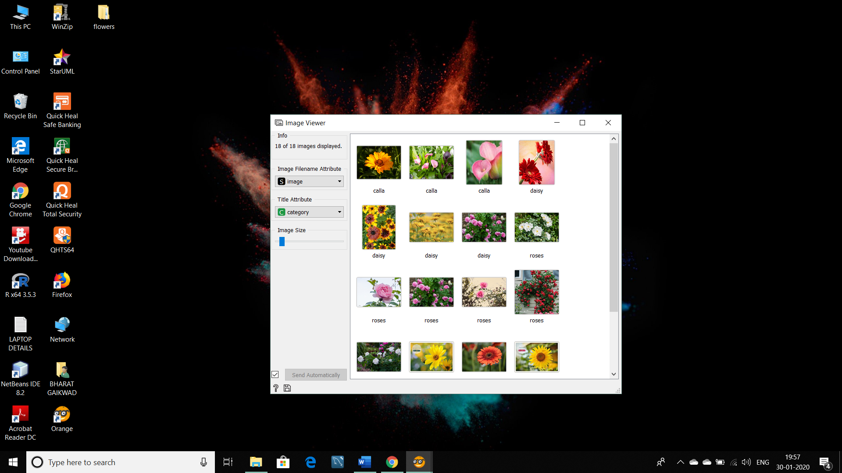

1. **Image Embedding:** Classification and regressions tasks requires data in the form of numbers and there isn’t a good way to perform such tasks with images unless we represent it in the form of numbers.

* This is where **Image Embedding** widget works by converting it to a vector of numbers. **Image Embedding** widget reads images and uploads them to a remote server or evaluate them locally.

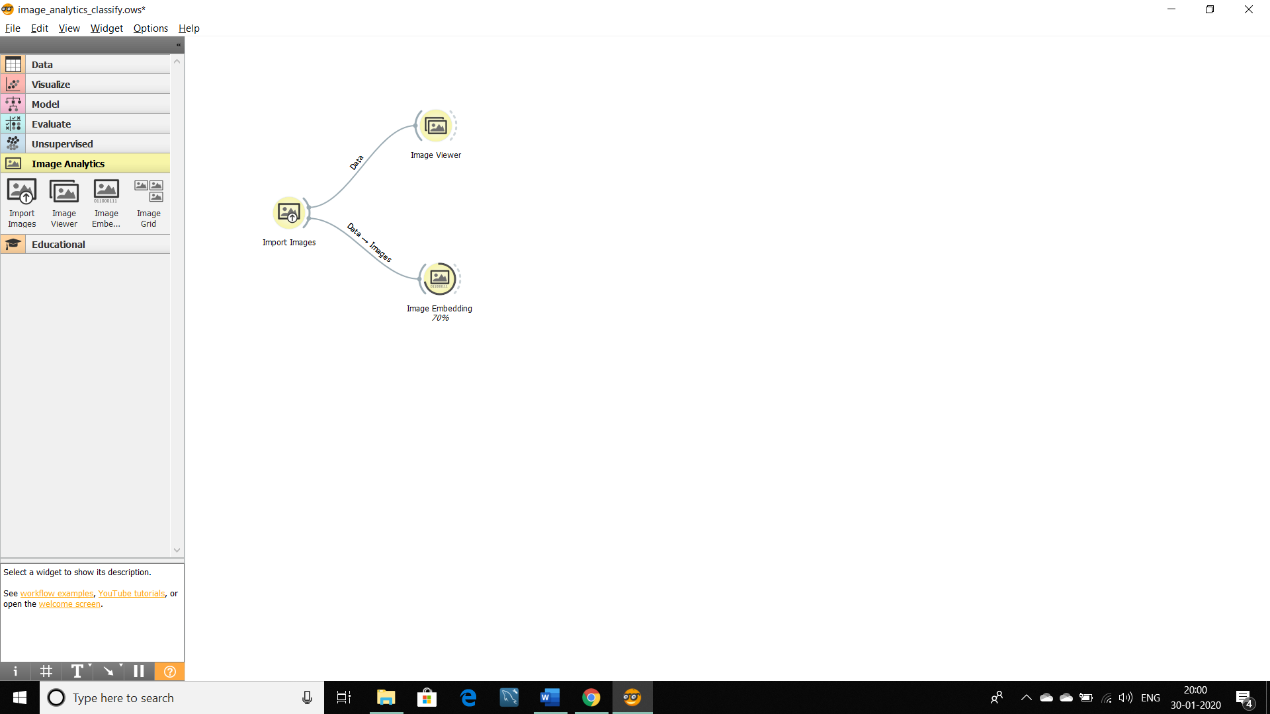

1. **Data Table:** Data Table widget receives one or more data sets for all images with their features and presents them in a spreadsheet format.

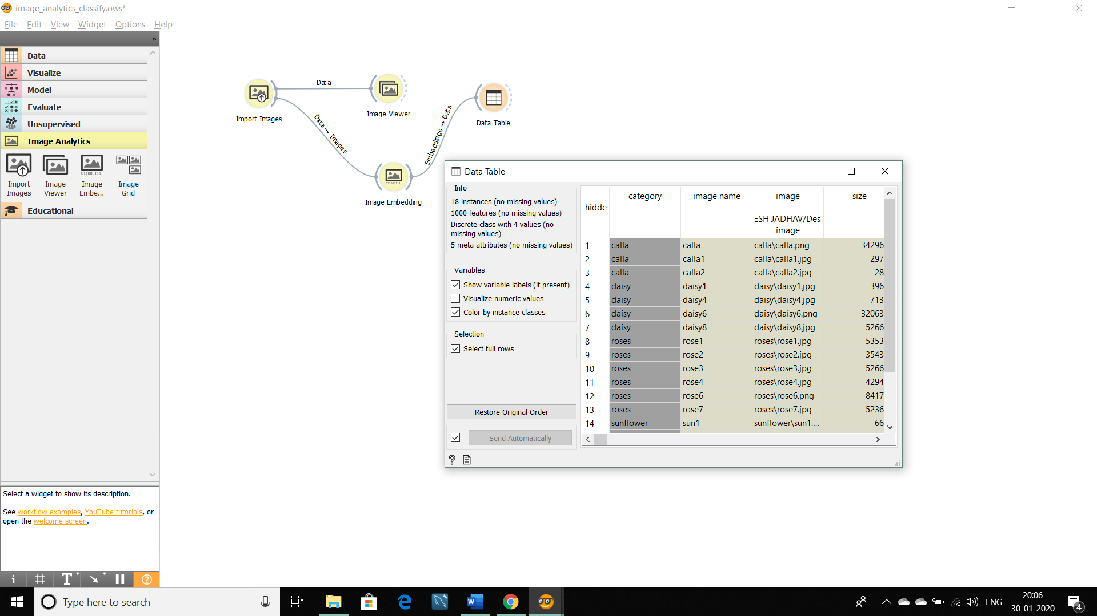

1. **Test and Score:** For cross validation accuracy estimation, we use test and score widgets. But for that, we have to connect test and score to logistic Regression.

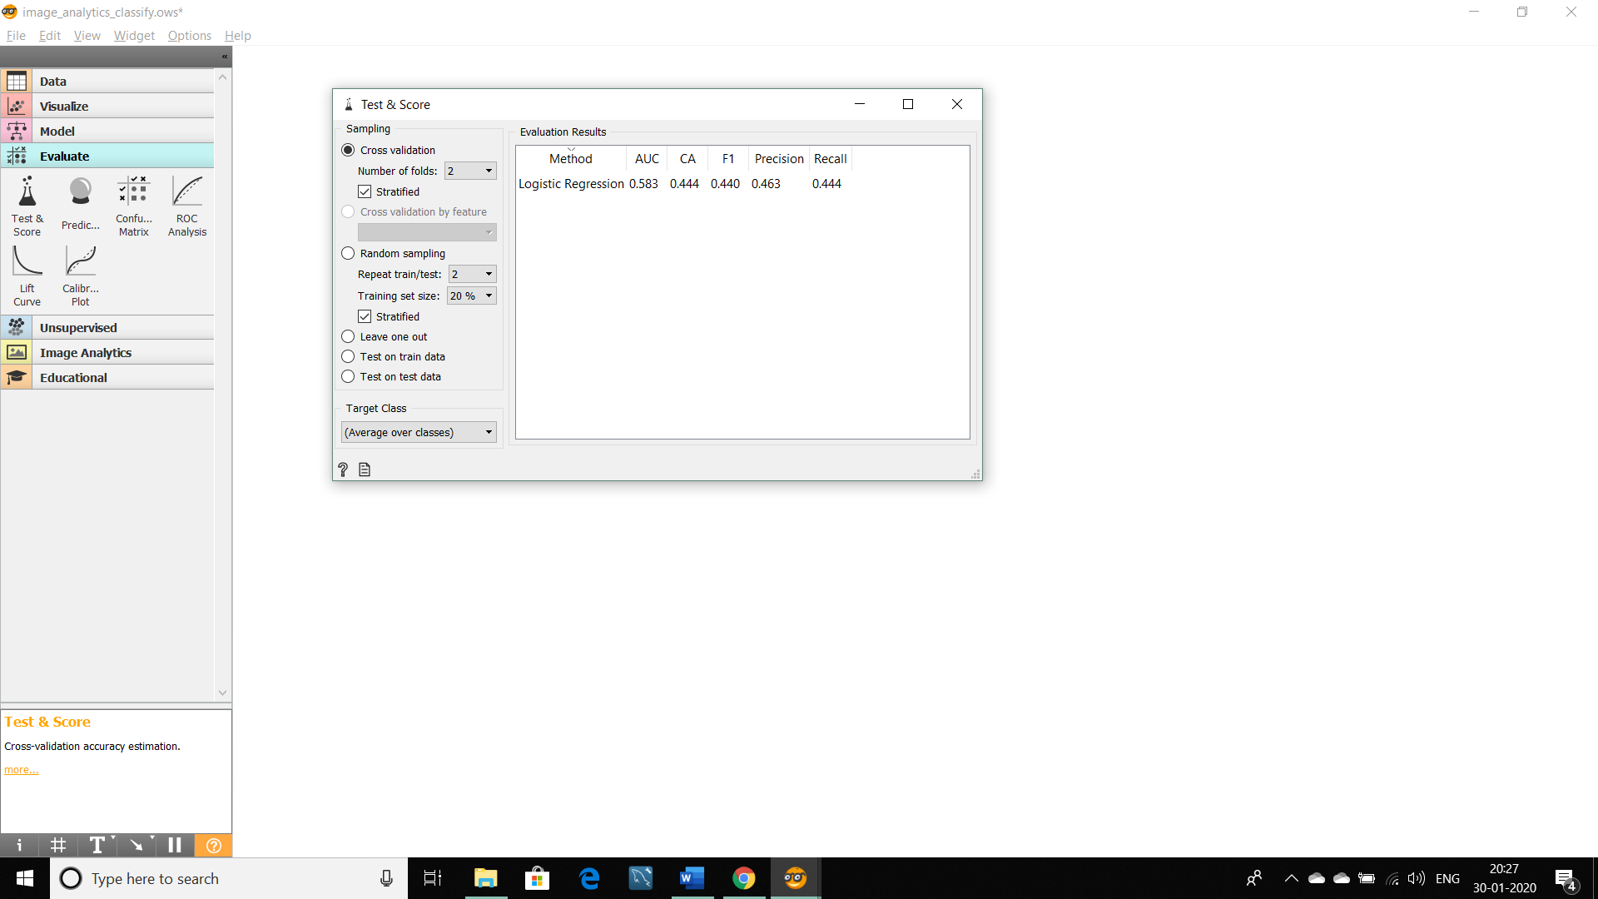

1. **Logistic Regression:** The widget is used just as any other widget for inducing a classifier. **Logistic Regression** learns a [Logistic Regression](https://en.wikipedia.org/wiki/Logistic_regression) model from the data. It only works for classification tasks.

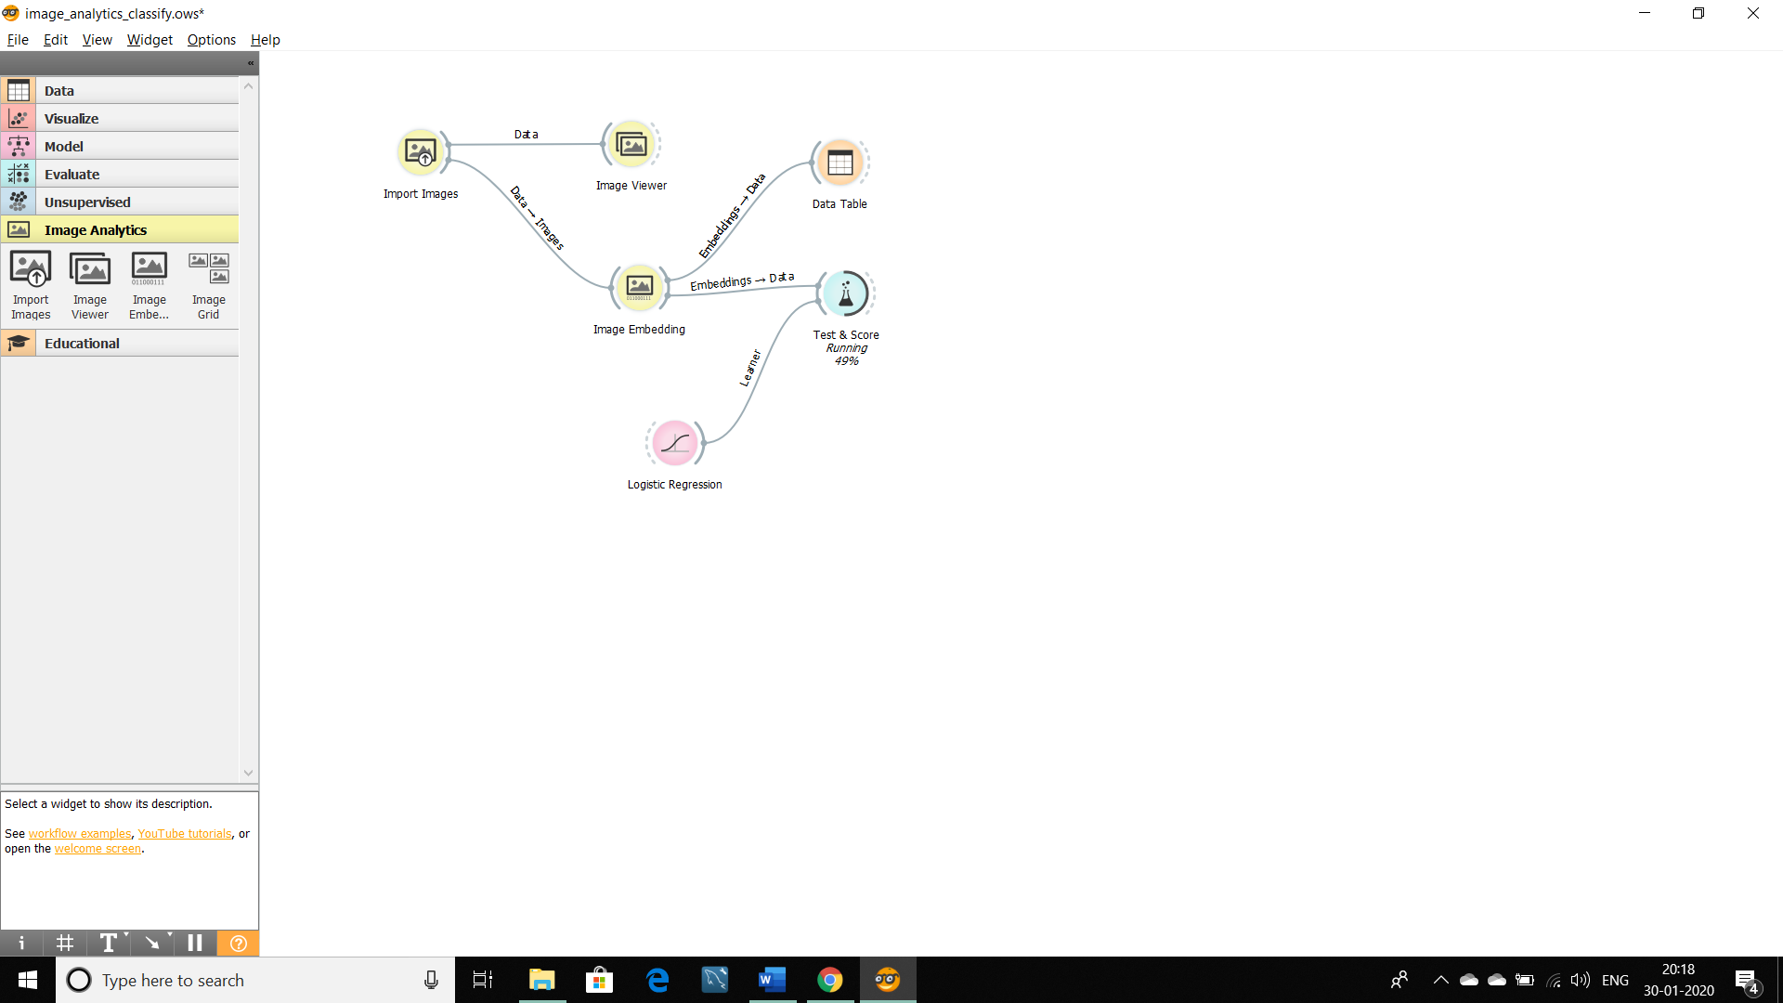

1. **Confusion Matrix:** The [Confusion Matrix](https://en.wikipedia.org/wiki/Confusion_matrix) gives the number/proportion of instances between the predicted and actual class.

From the table, we have to select one cell from misclassified to see the specification.

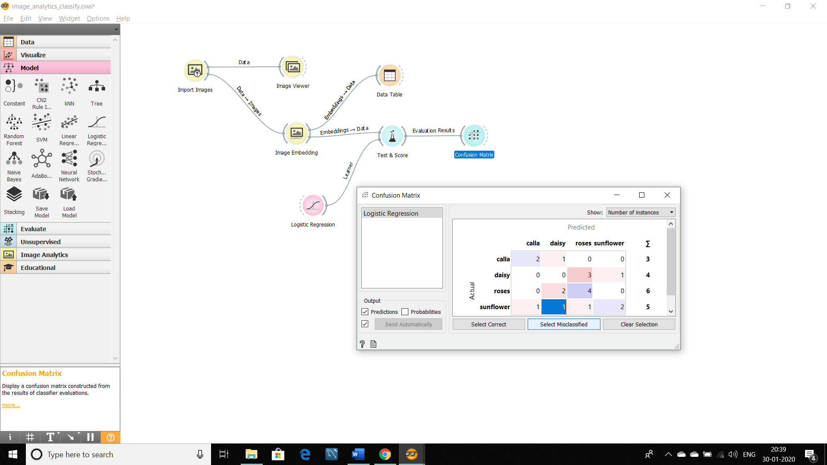

1. **Image Viewer:** After selecting the cell, we can see the specification between actual and predicted classes of images in an image viewer.

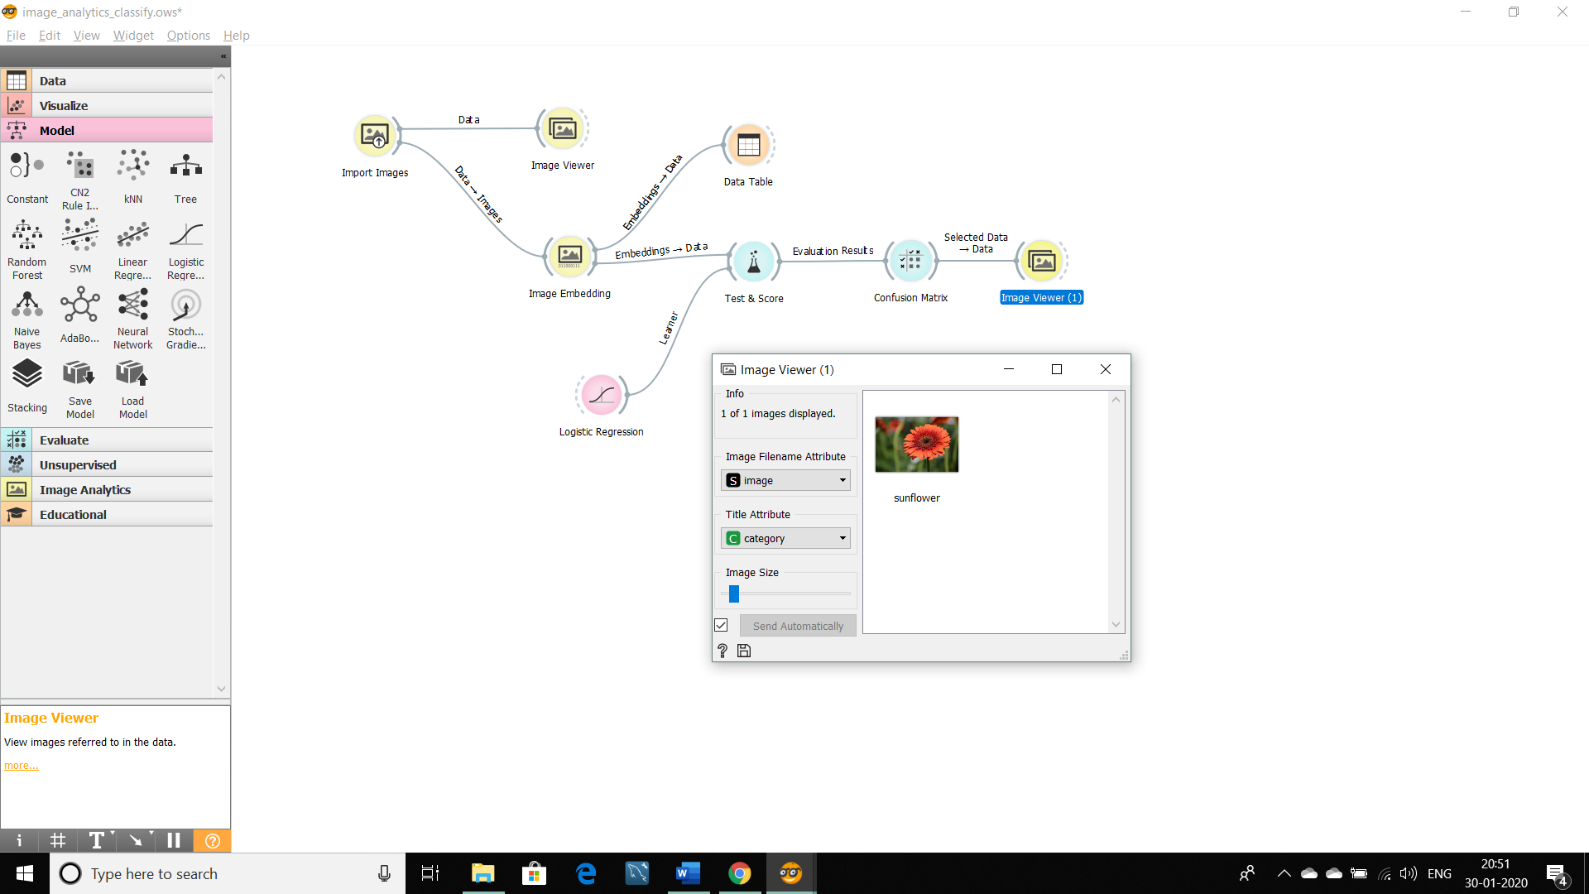

**Image Analytics-Classification:**

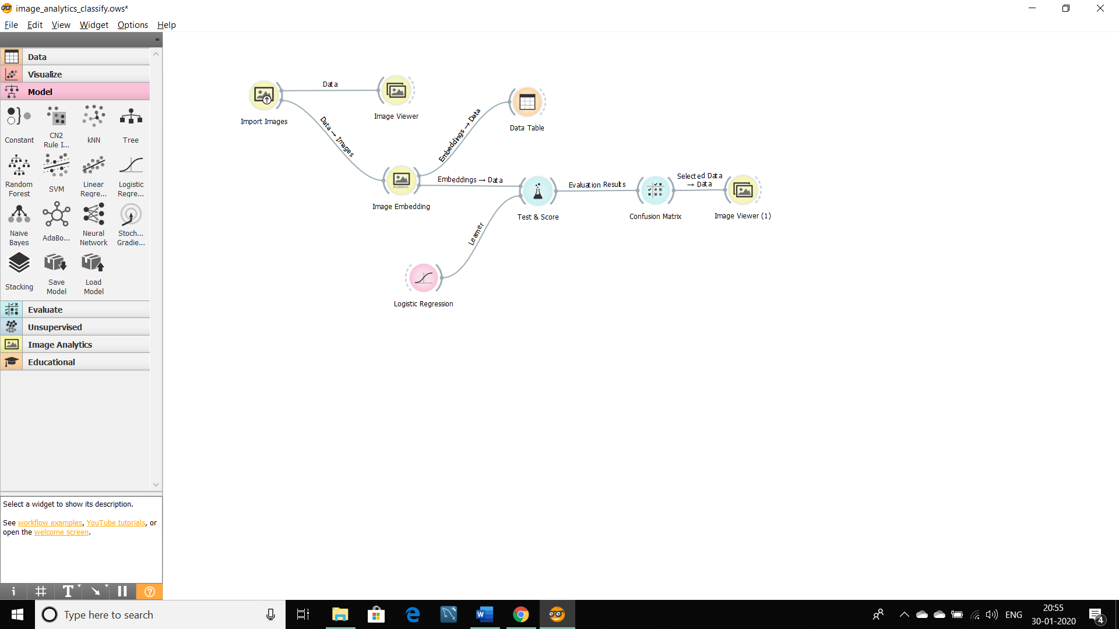

**Practical No.: 4**

**Aim:** Hierarchical clustering in orange.

**Solution:**

Open Application -> Orange -> Select new file

Select File -> double click on it ->Select the table from the file as iris.tab.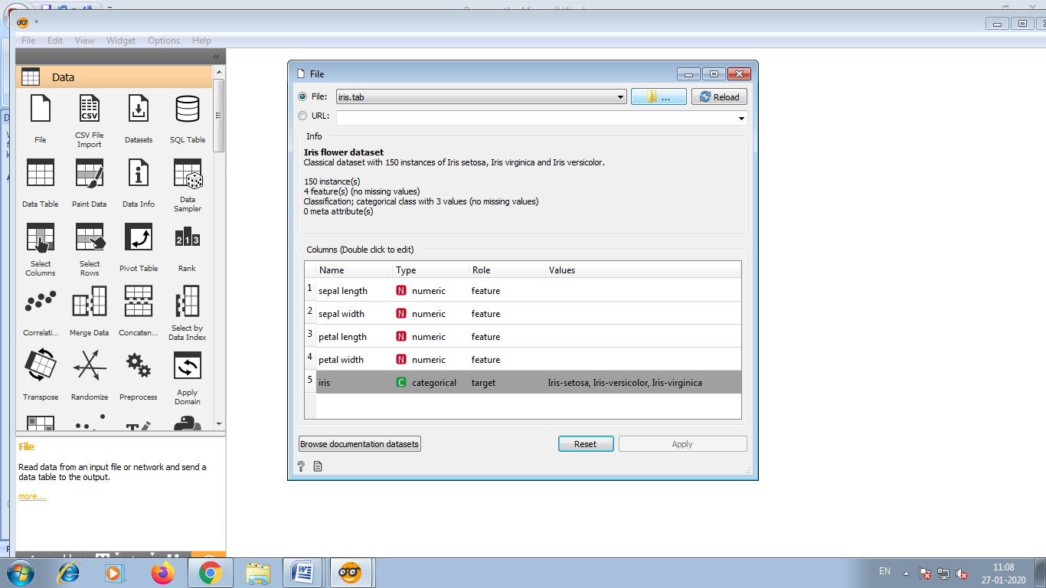

After selecting iris.tab, open it .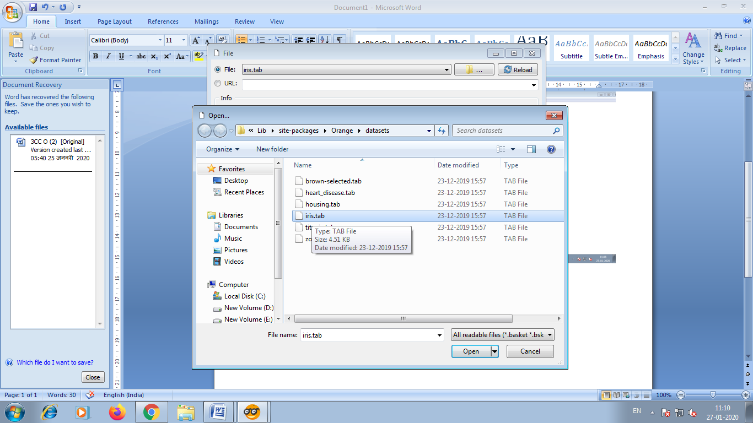

Directly close the current window as shown in below.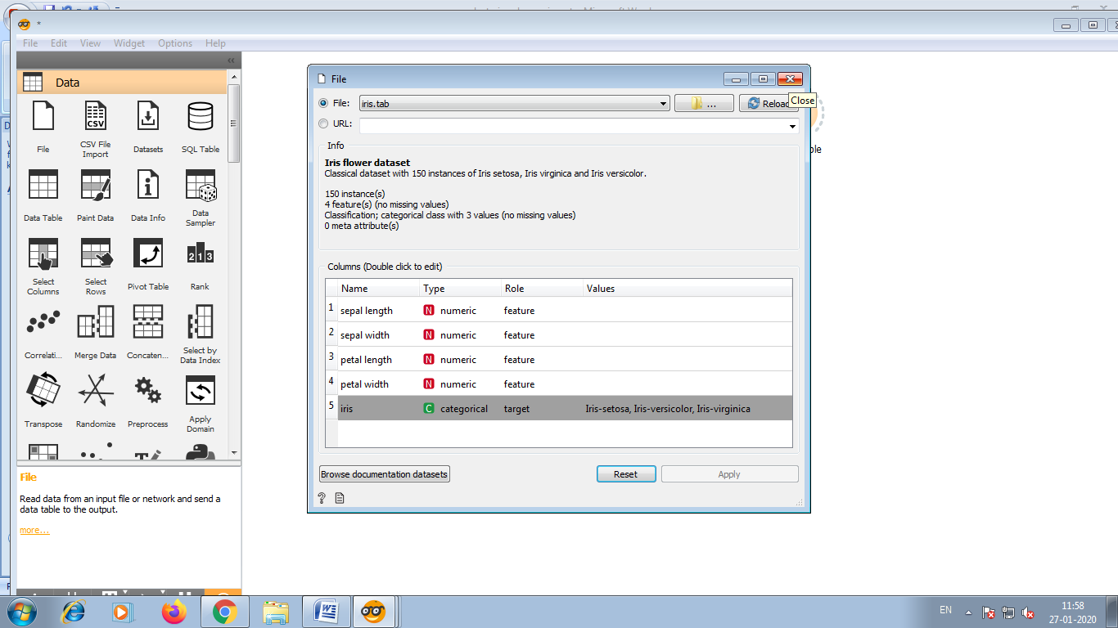

Click on the file and select Distances from the list.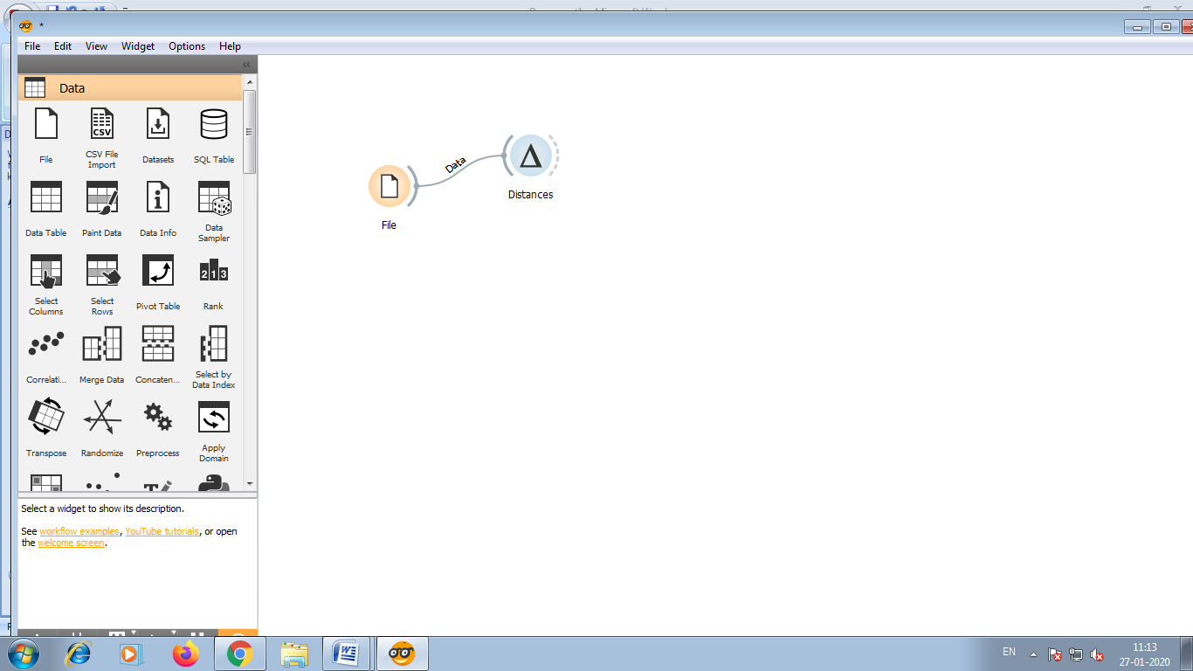

Again by clicking on distances select the hierarchical clustering .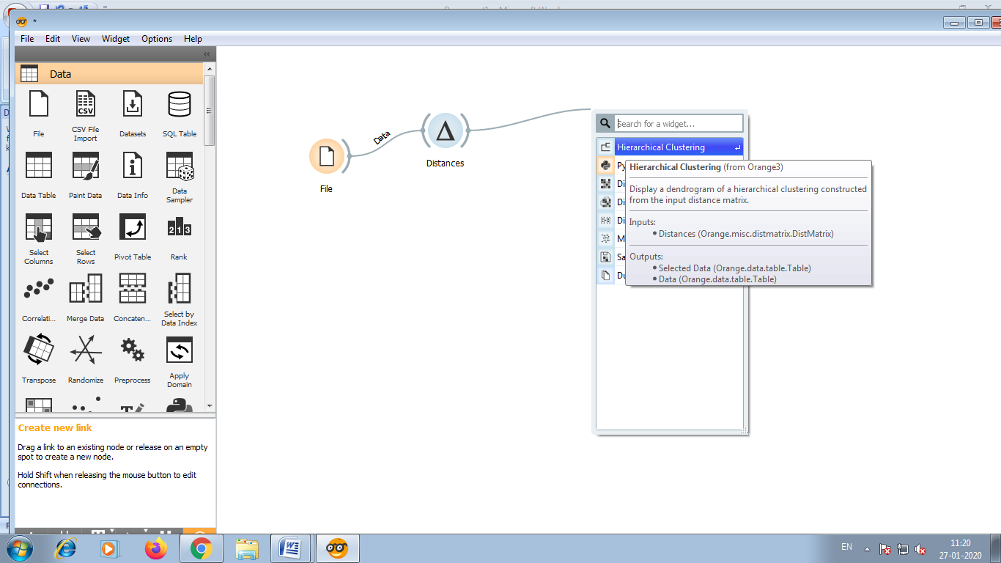

After selecting hierarchical clustering it look like this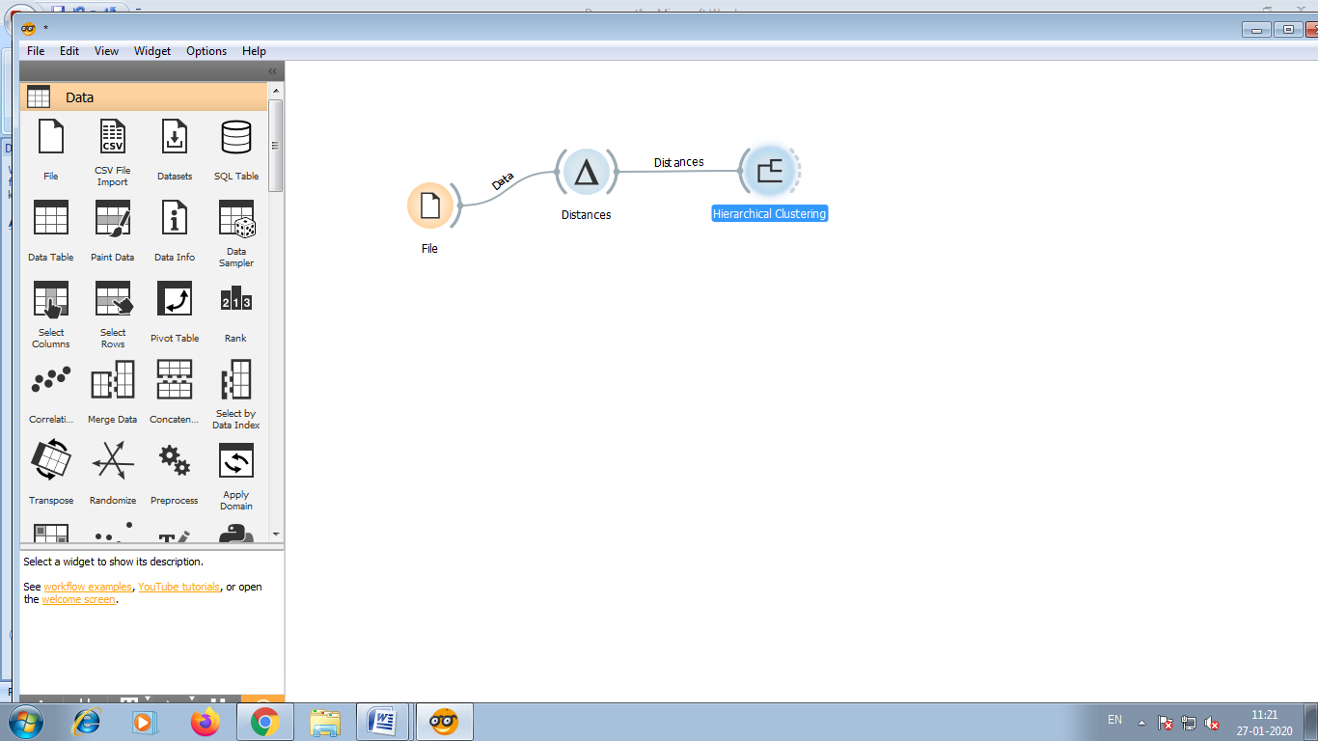

Now double click on hierarchical clustering, you will see the picture of hierarchical clustering.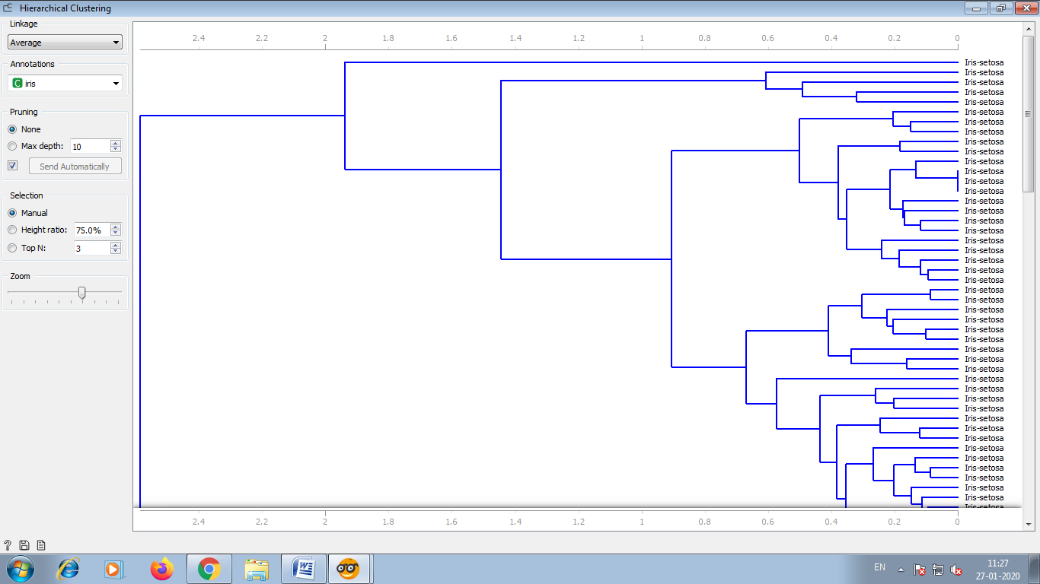

Now select the sub-cluster as shown in below.

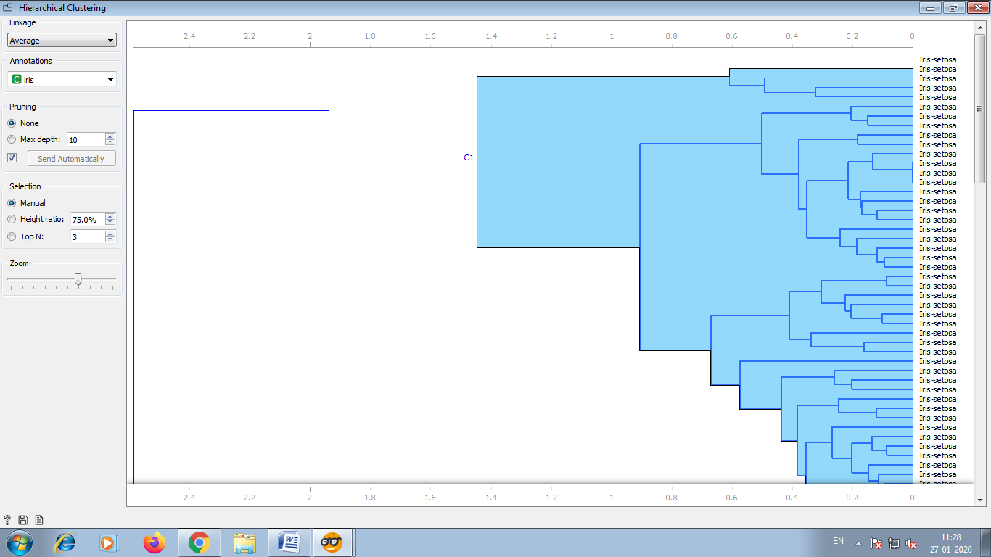

Now by clicking on hierarchical clustering select the data table.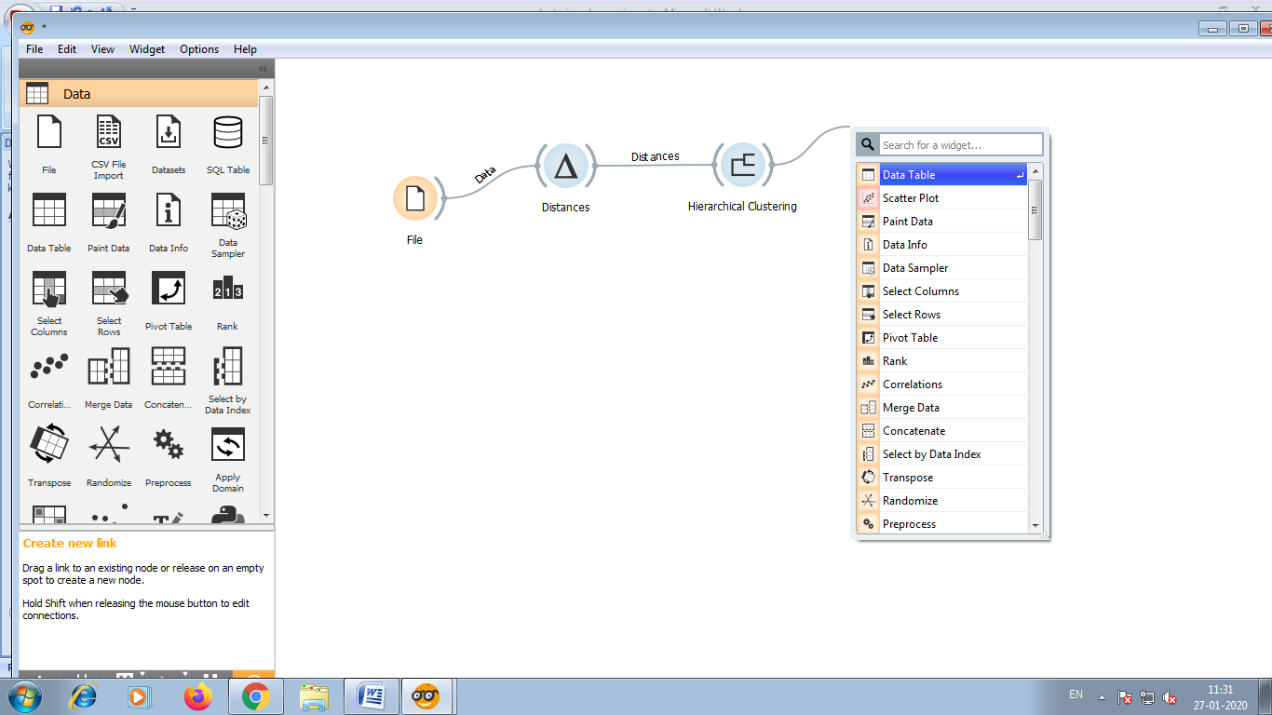

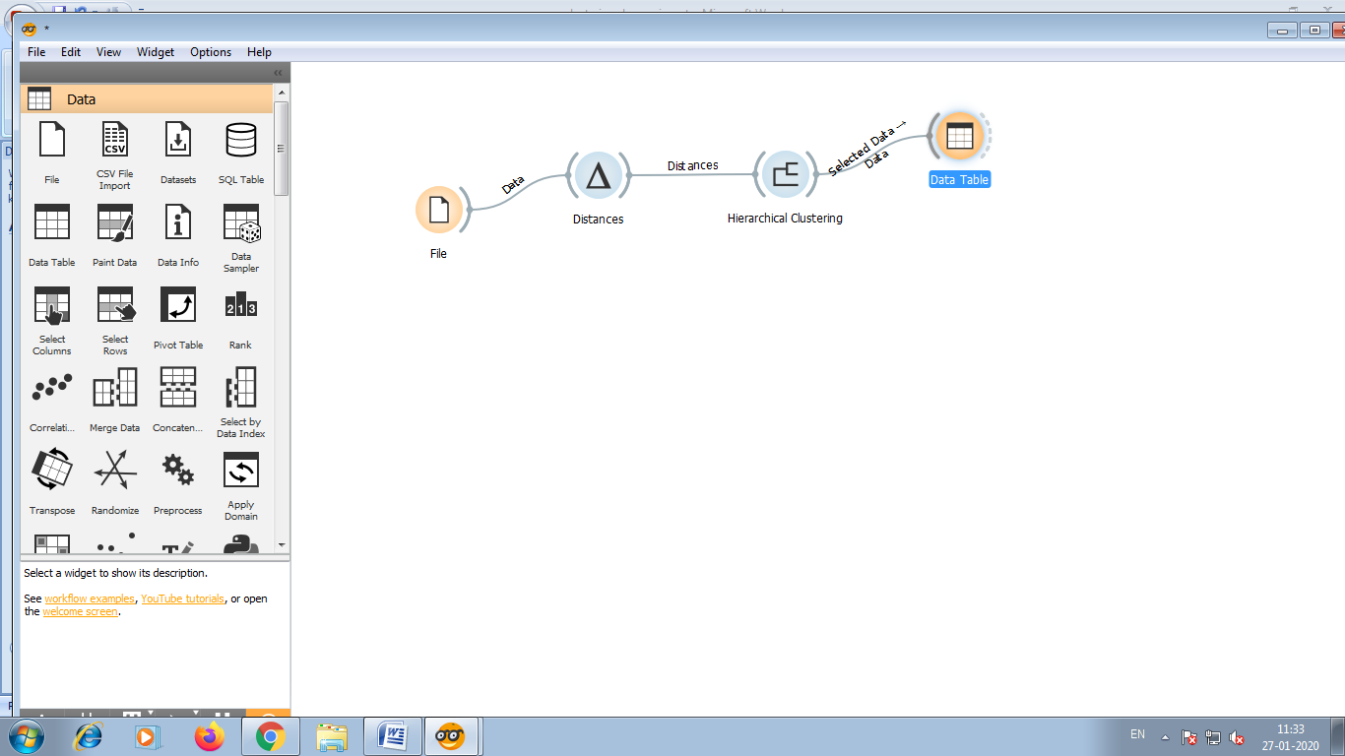

By double clicking on data table you will see the data which you have selected.

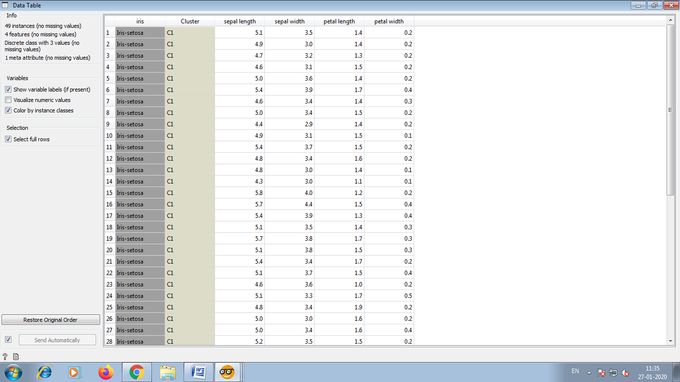

Now by clicking on file select scatter plot.

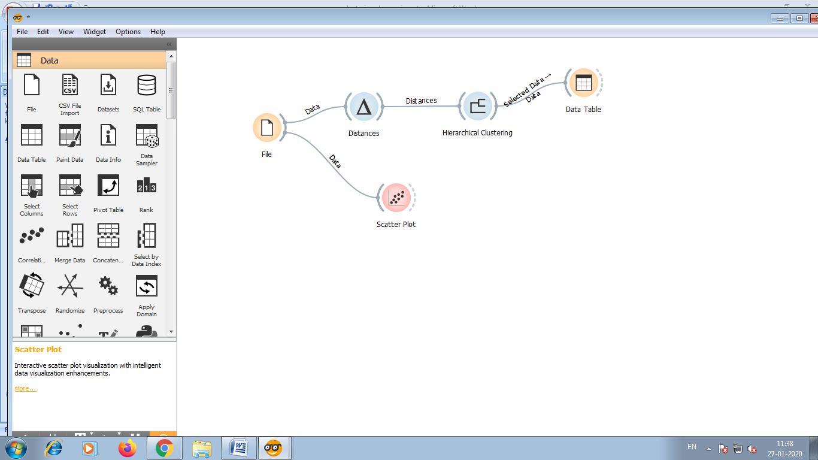

* By double clicking on scatter plot you will see the different colours , which shows the different type of clusters as shown in below figure.
* Cluster of Iris-setosa is represented by blue colour, Cluster of Iris-versicolor is represented by red colour and Cluster of Iris-virginica is represented by yellow green.

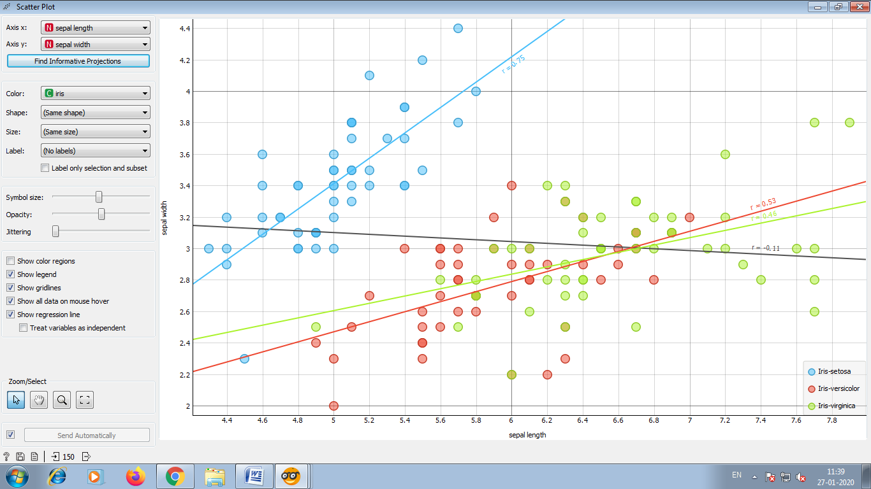

**Practical No.: 5**

**Aim :** Text preprocessing in Orange

**Solution :** Open->Orange->File->New

1)First we install the Text-Add-ons , Go to Options->Add-ons.

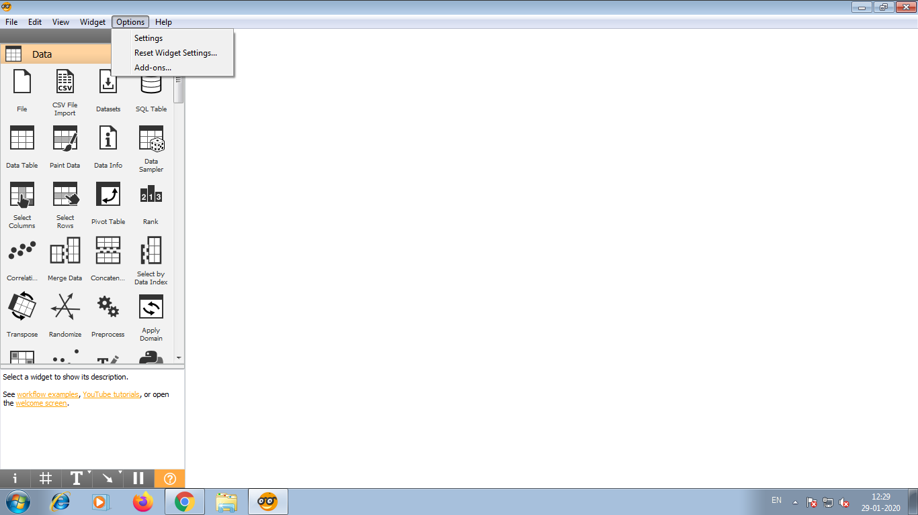

2)select Text-.

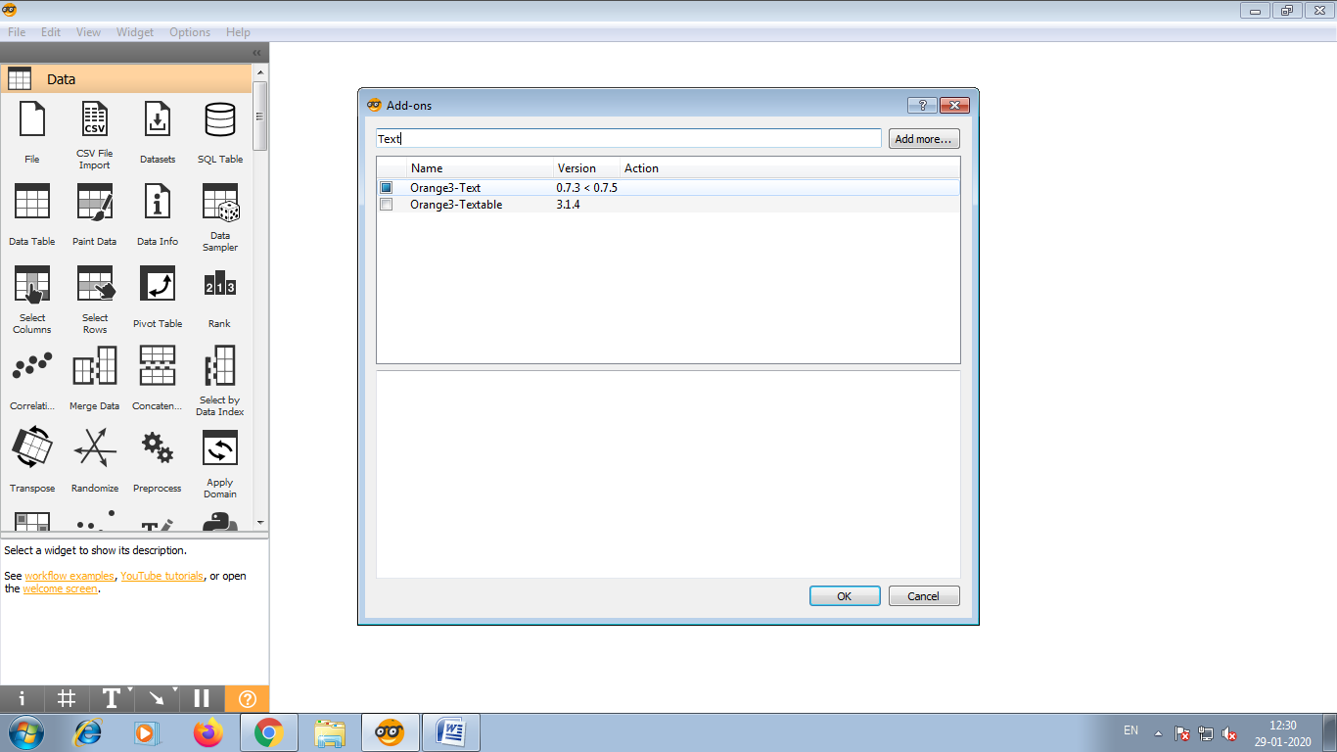

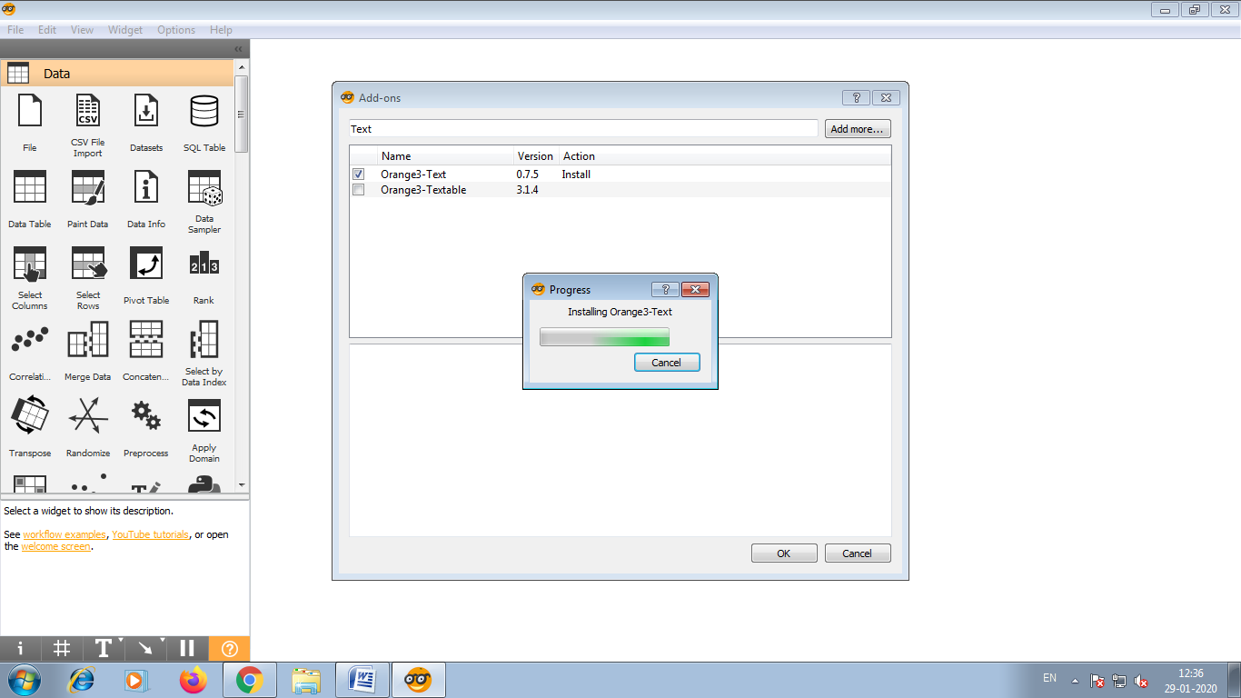

3)Restart orange to for the add-on to appear

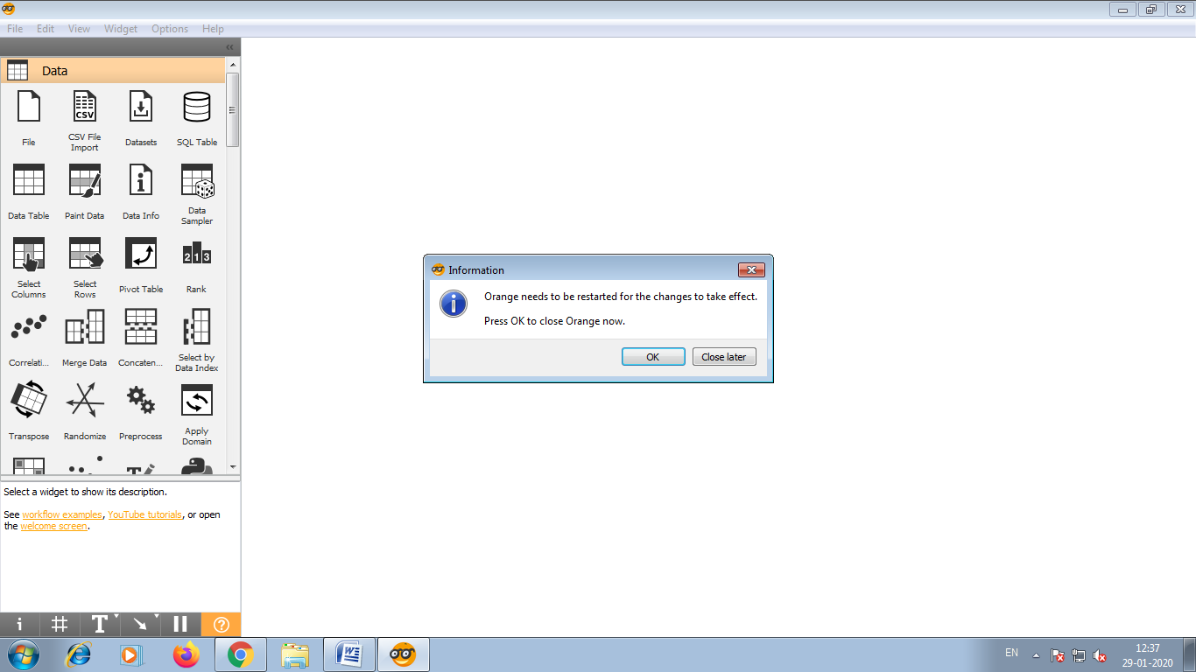

4)Now let us load the data ->Corpus

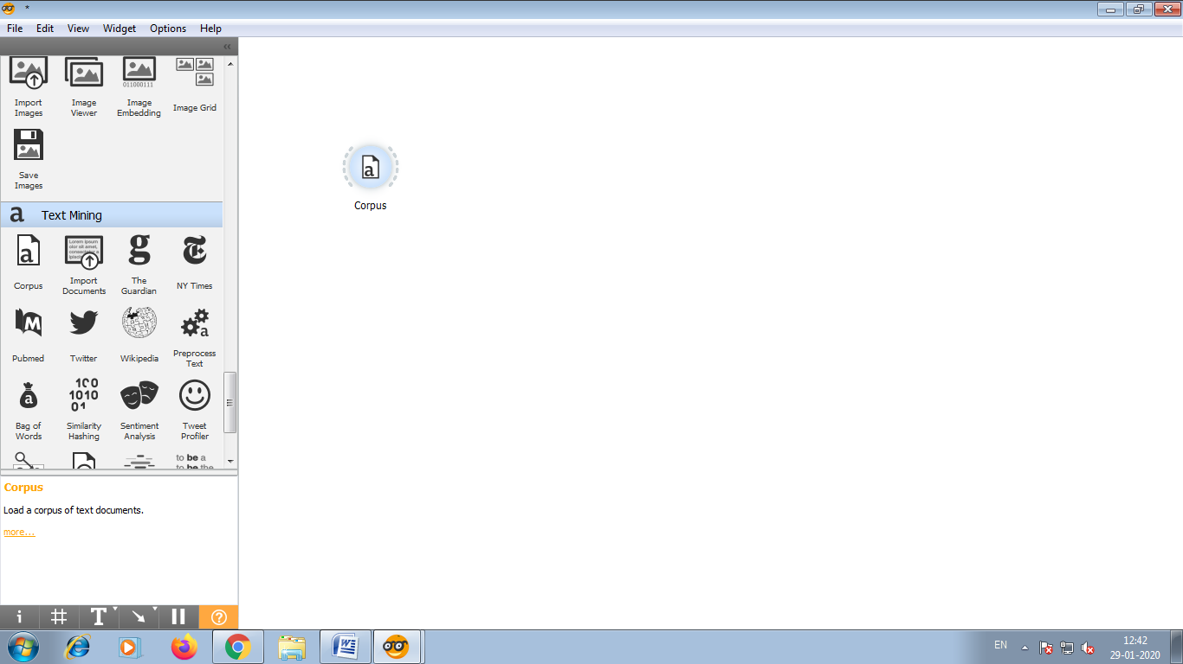

5)Place Corpus widget on the canvas and open it.Go to browse documentation Corpora ->Select ->and load Grimm-Tales-selected.

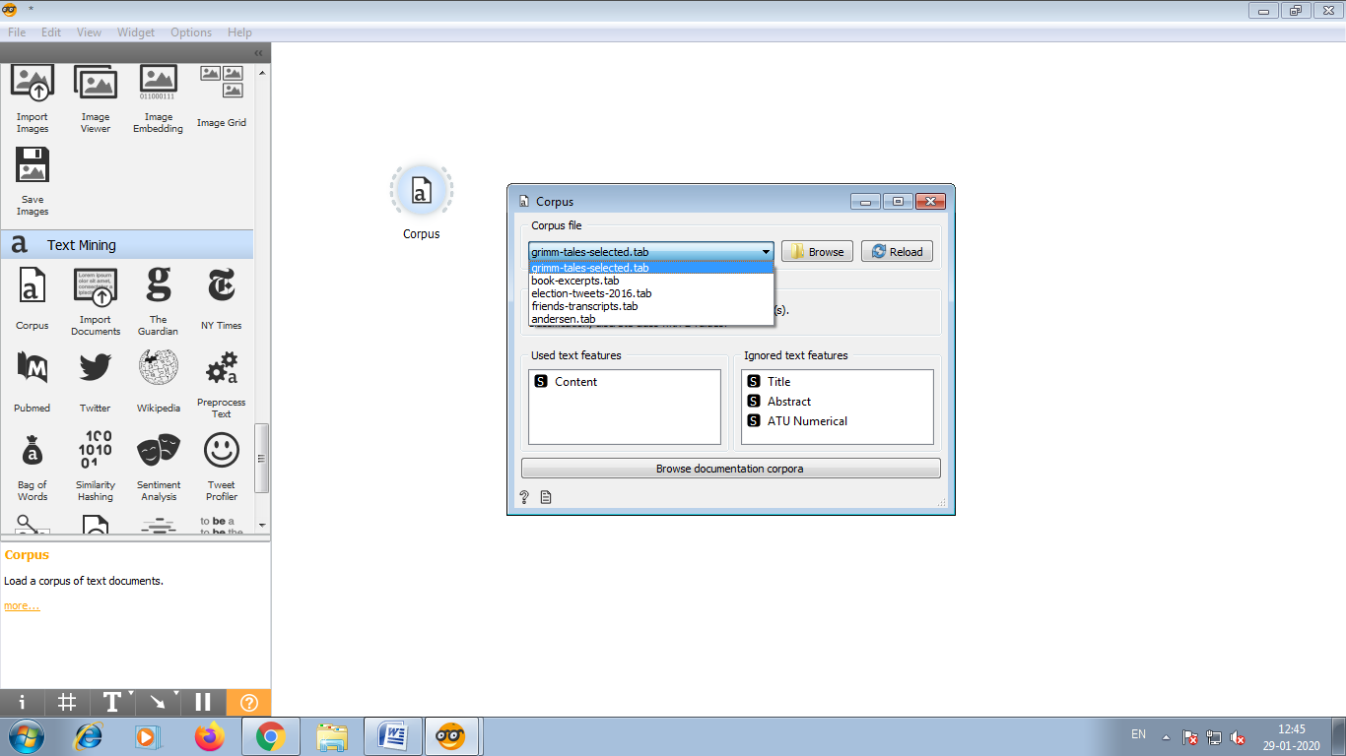

6)We have 44 Grim tales on the output of the widget.

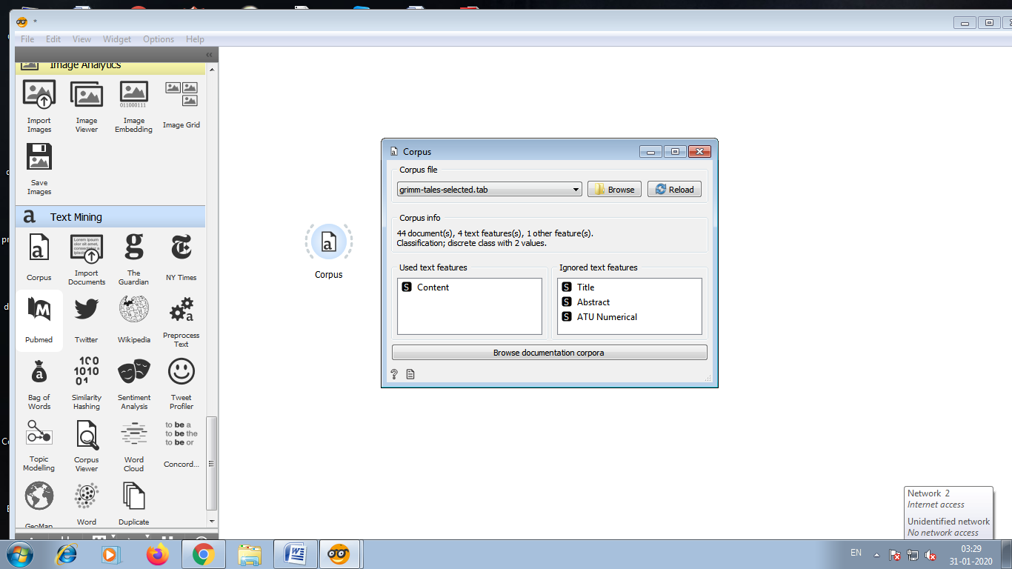

7)Connect Corpus viewer to corpus.

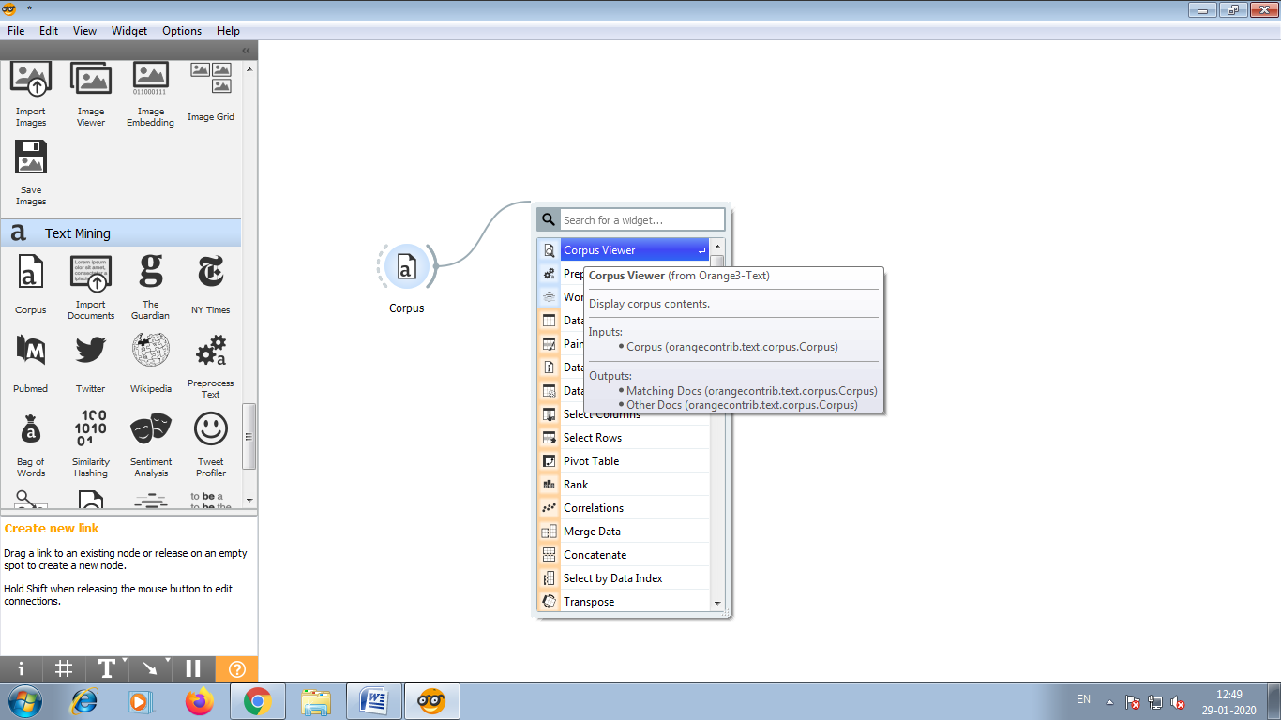

8)Corpus viewer displays text and enable us to browse it.

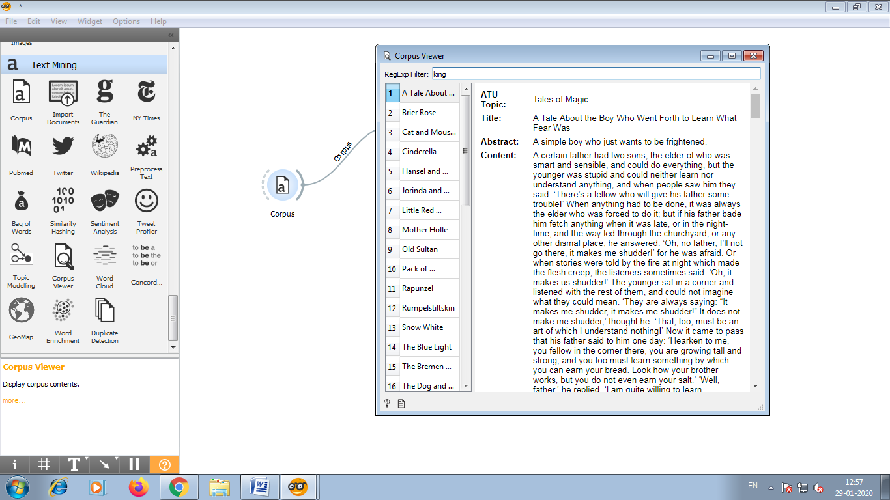

For example, we can output only those document that contain the word “king”.

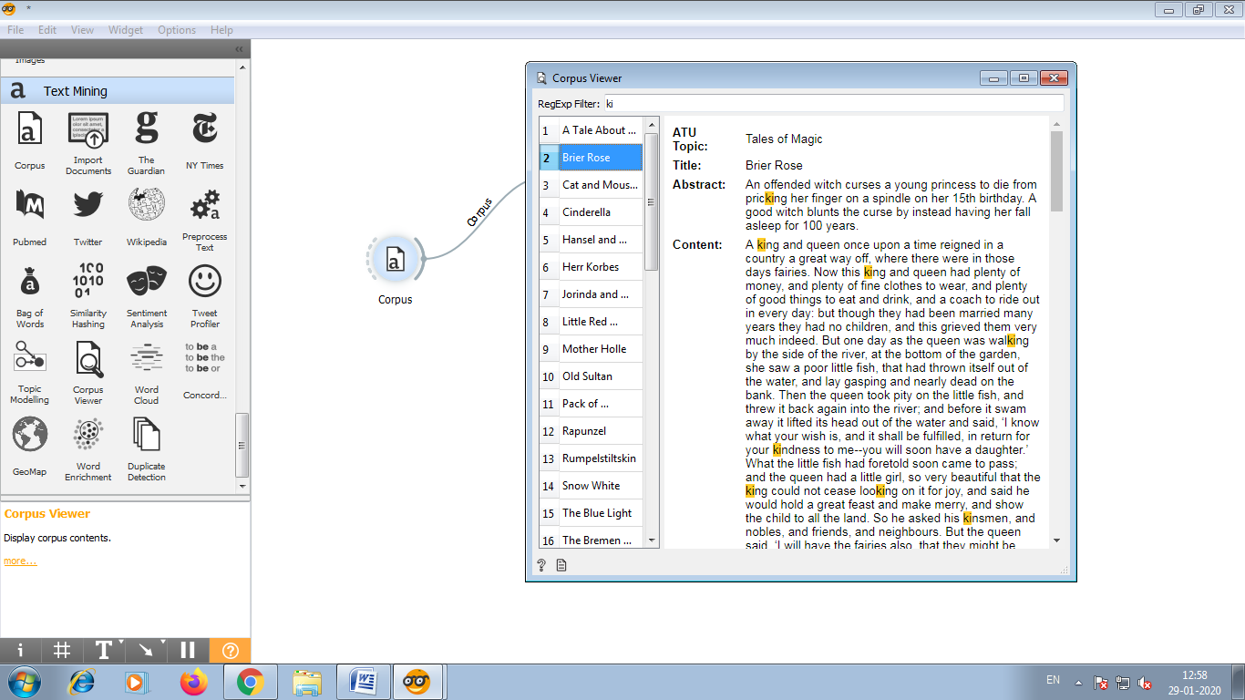

9)Another widget for visualizing the text is word cloud.

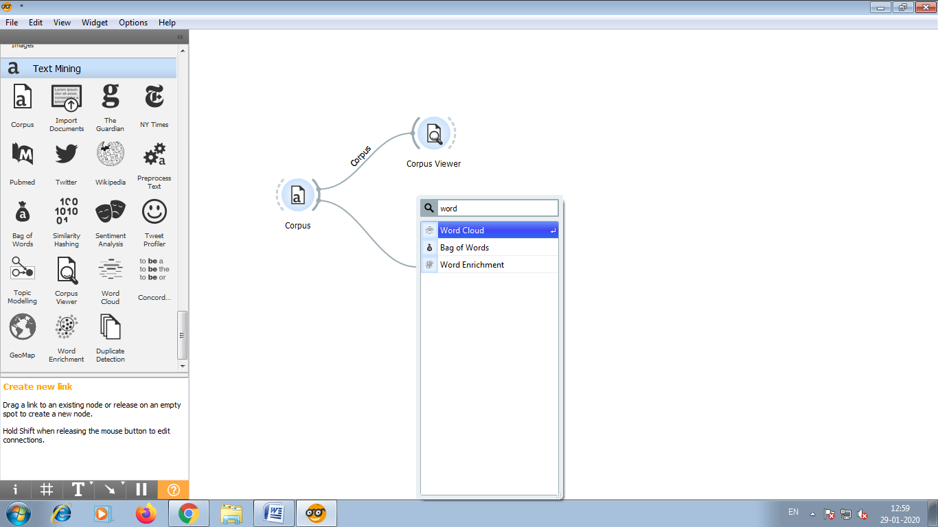

10)The widget displays word frequencies in a cloud.The more frequently the word appears in the text the larger the word will be. Our word cloud show words such as punctuation and uninformative words.

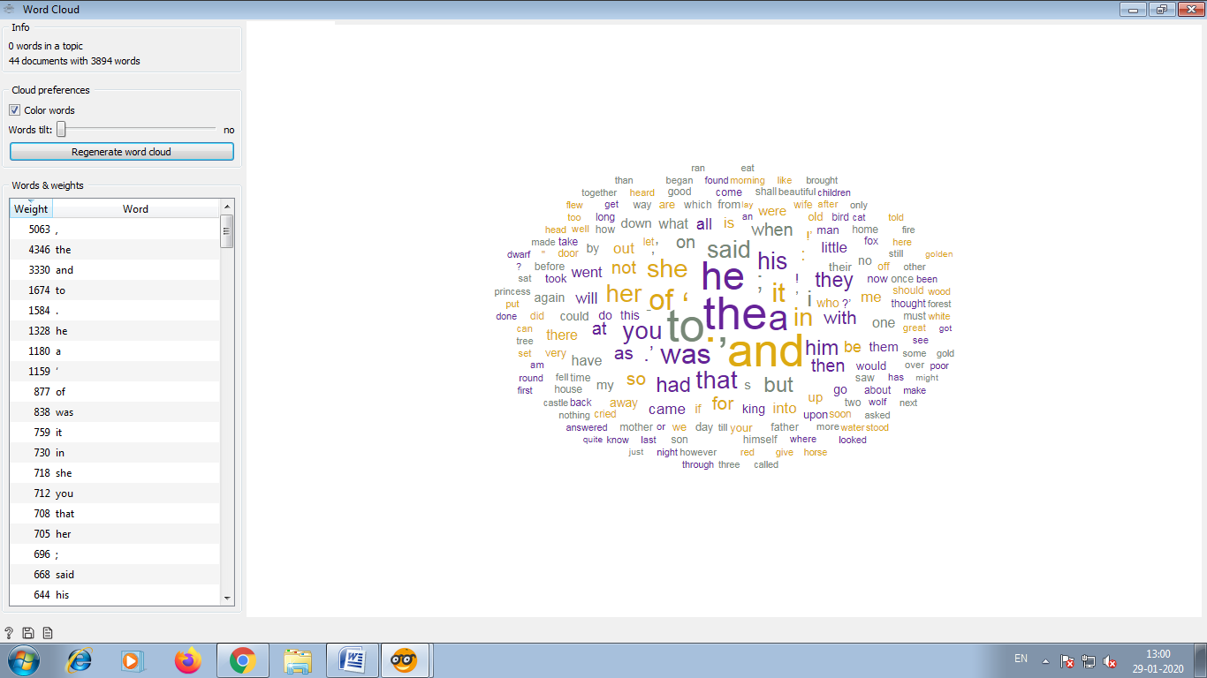

11)To getting rid of this we will now use preprocess text.

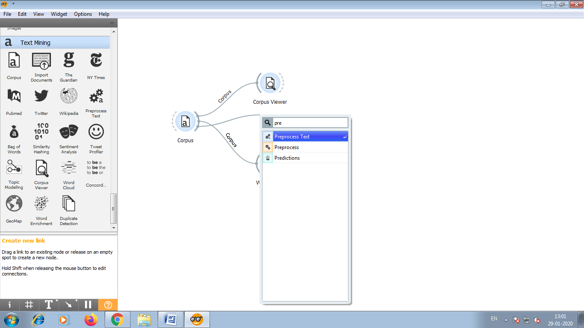

12)This widget will transform all text to lowercase. Next it will convert text into individuals words and omit the punctuation.

Individuals word are called tokens.

Finally it will filter out stopwords.

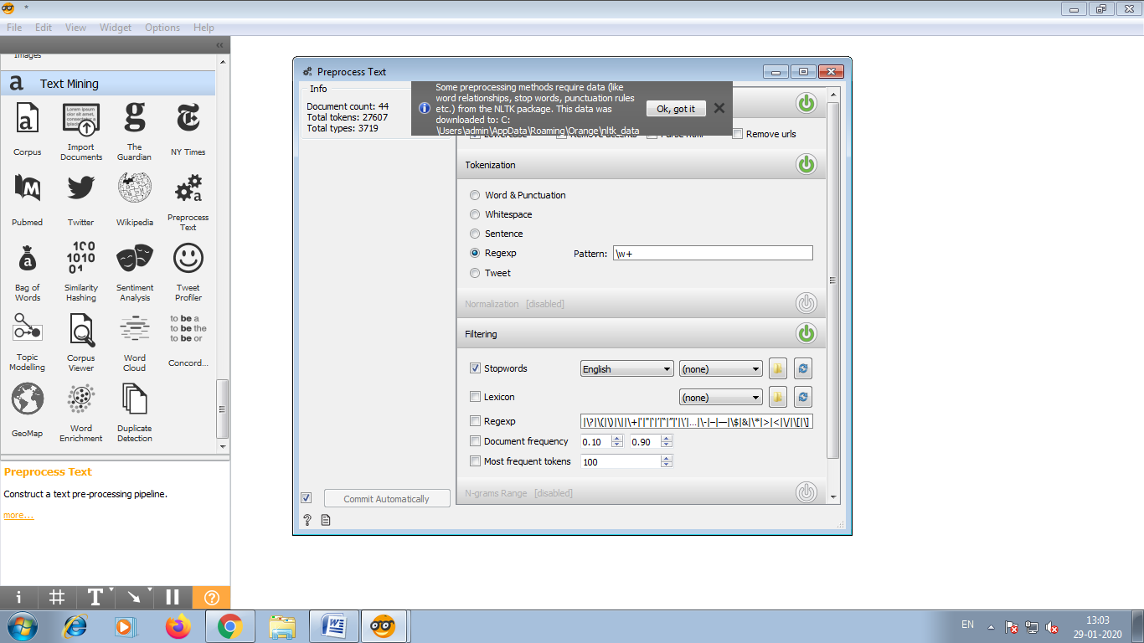

13)The effects of preprocessing can be visually explored in the word cloud.After preprocessing this visualization looks much better.

14)Connect another word cloud with preprocess Text. In this we retained only meaningful words.

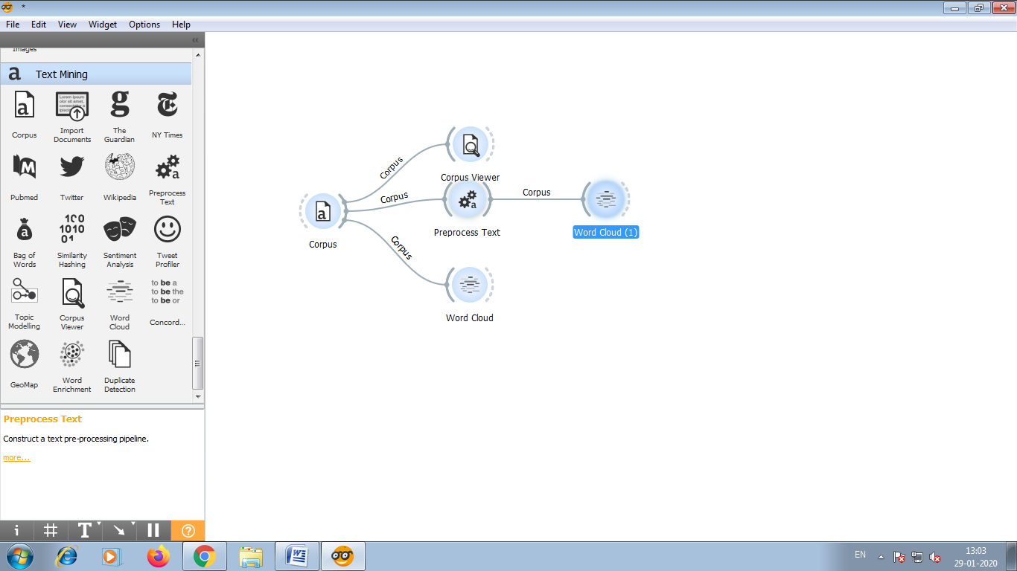

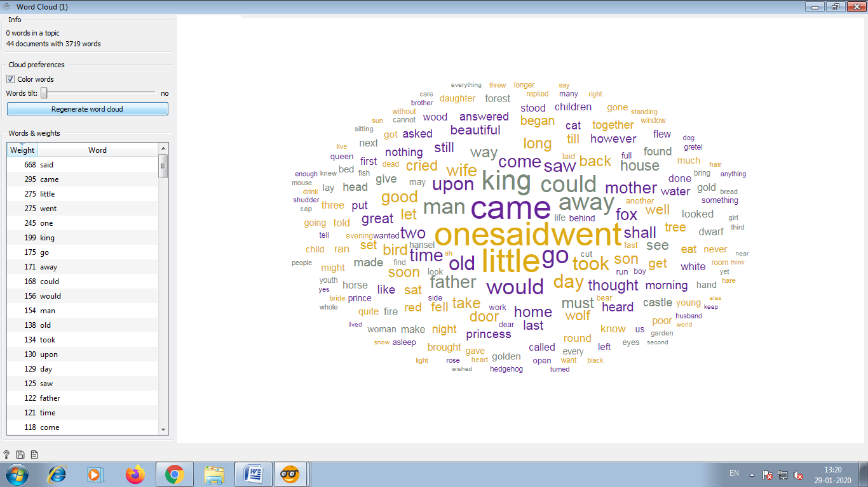

**Practical No.: 6**

**Prediction in orange**

**Aim**: To predict whether the given dataset is of fruit or vegetable.

**Description**:

This dataset contain numerous feature which diffrenciate whether the given dataset is of vegetable or fruit. The target variable is classification i.e Is it fruit or vegetable.

**Data selection:**

We have given the url of the dataset which contain 35 instances and 9 features of fruit and vegetables.

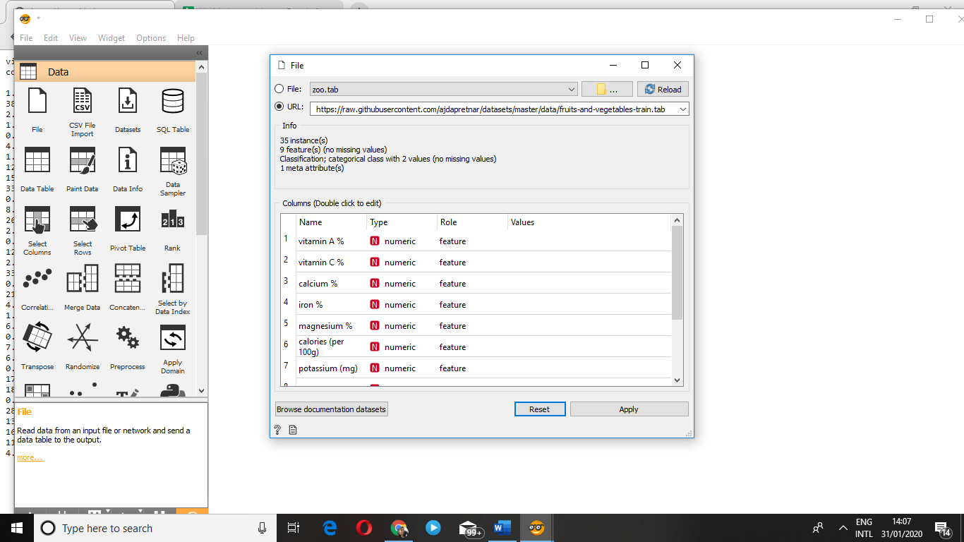

Data visualization:

We visualize the data by using data table and classification tree.

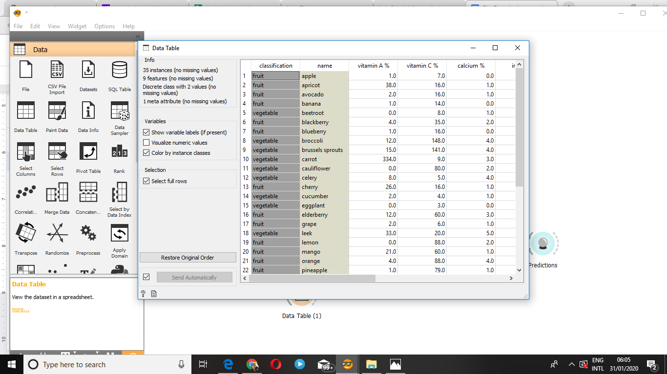

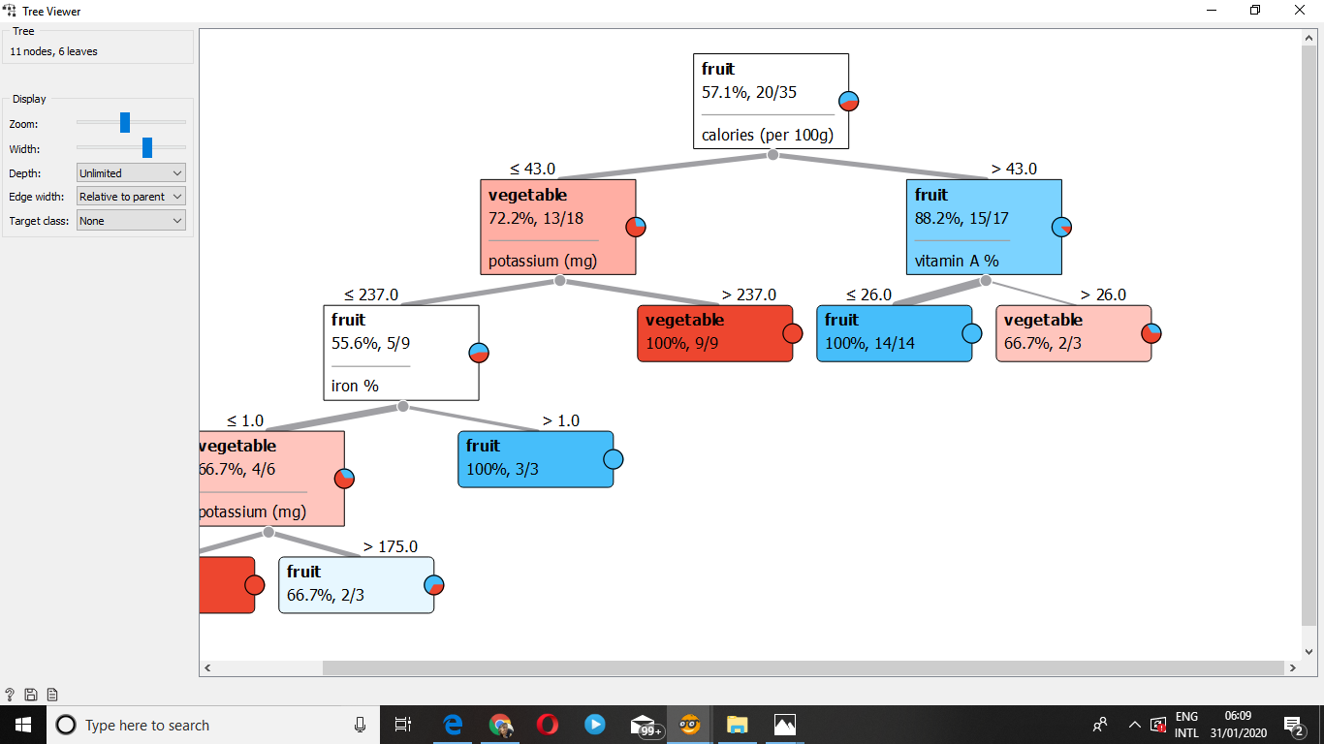

Again ,You have to create the the dataset of plants which you need to predict and visualize it in data table. 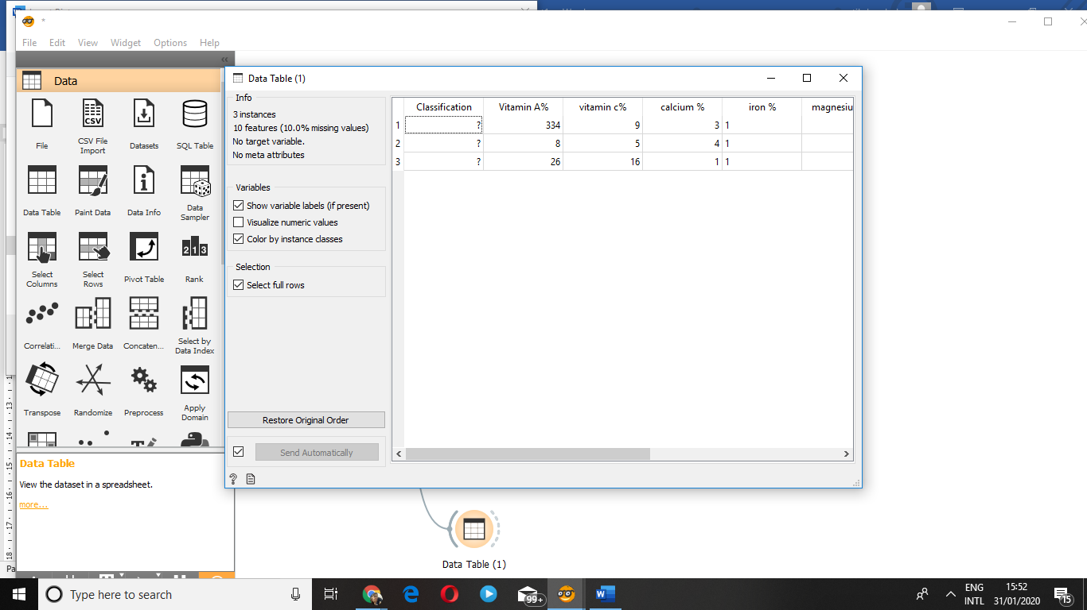

By using prediction widget you need to predict whether the plant is vegetable or fruit .

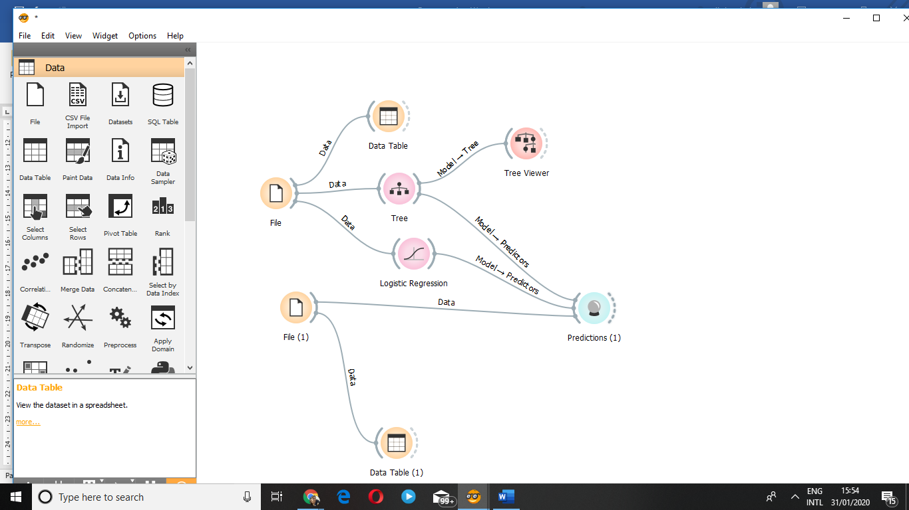

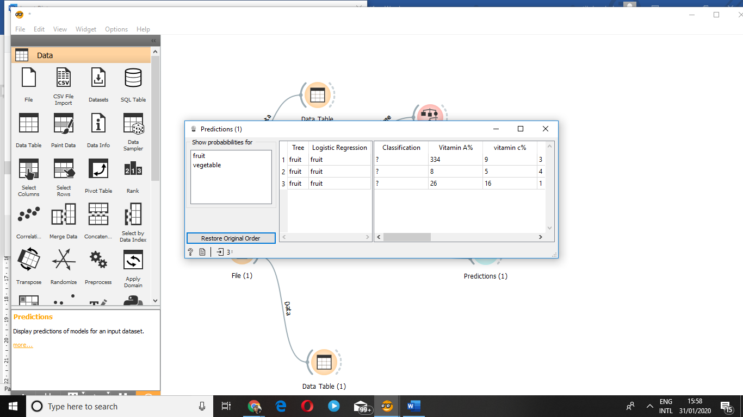

The given prediction is again checked by logistic regression.

## Practical No.: 7

## Rain Tomorrow Prediction in Orange

#### **Aim:** Predict whether or not it will rain tomorrow by training a prediction model on target variable RainTomorrow

#### **Description**: This dataset contains daily weather observations from numerous Australian weather stations.

The target variable RainTomorrow means: Did it rain the next day? Yes or No.

#### **Data Selection**:

We have downloaded the dataset ( [weather dataset](https://www.kaggle.com/jsphyg/weather-dataset-rattle-package) ) of Australian weather stations which contains about 10 years of daily weather observations from numerous Australian weather stations.

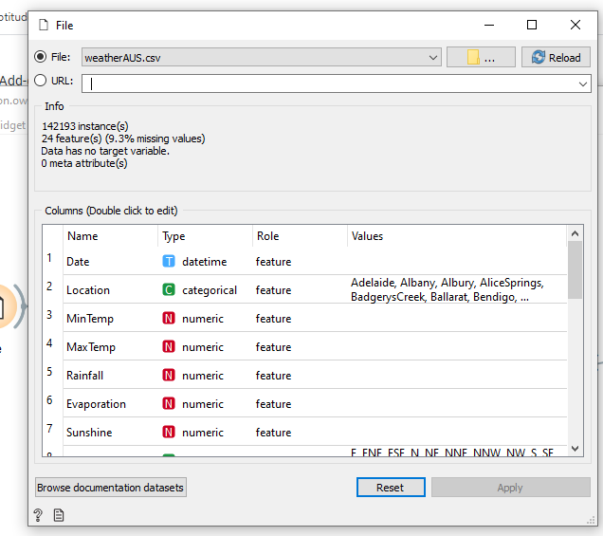

#### **Data Cleaning**:

In data cleaning, we will select the required column and remove the rows with missing values as shown below:

**Column Selection**

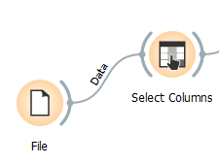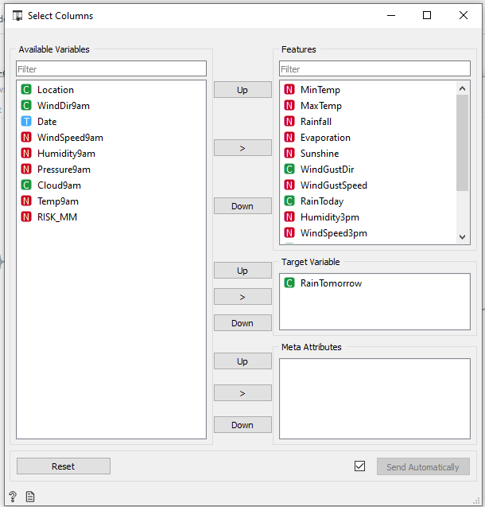

**Removing rows with missing values**

We will use the impute function to remove rows with missing values for columns “Sunshine” and “Evaporation”

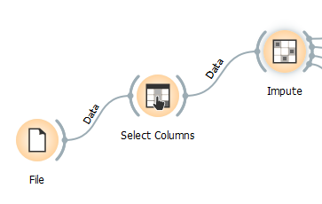

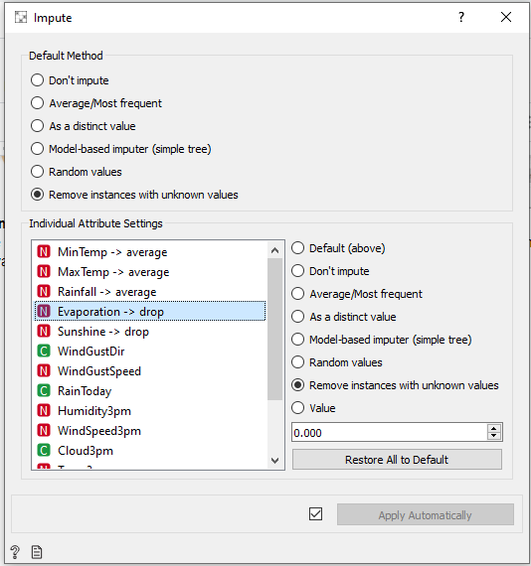

#### **Data Visualization**

In this step, we see the reflected data selection in data table. Then, we use scatter plot to visualize the data for better understanding of our dataset.

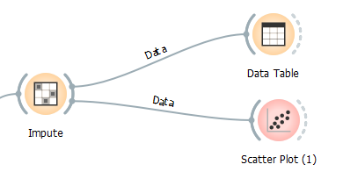

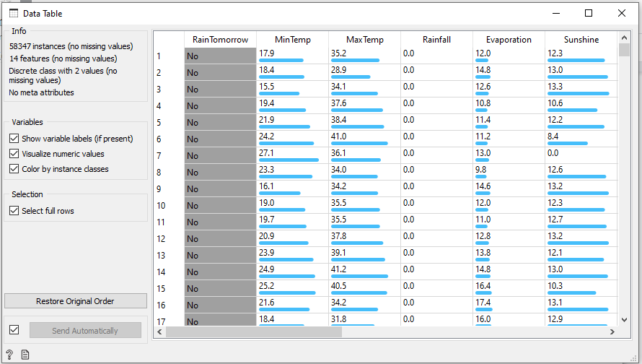

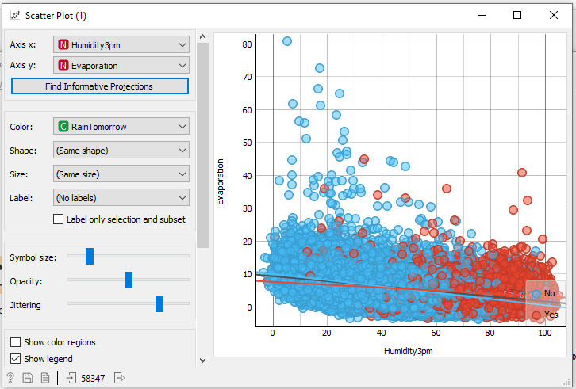

In the above scatter plot we see, as the humidity level increases and evaporation rates are low the chances of rainfall increases (red dots)

#### **Data Modeling**

In this step, we use **Logistic regression** to model our data. Then, we use “test and score” function to evaluate the performance of our model. Finally, we use “confusion matrix” to understand the prediction.

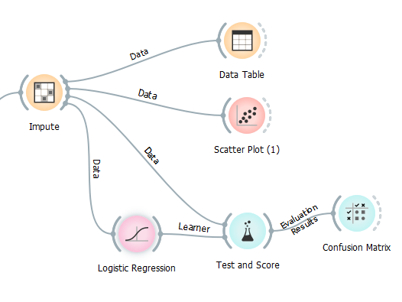

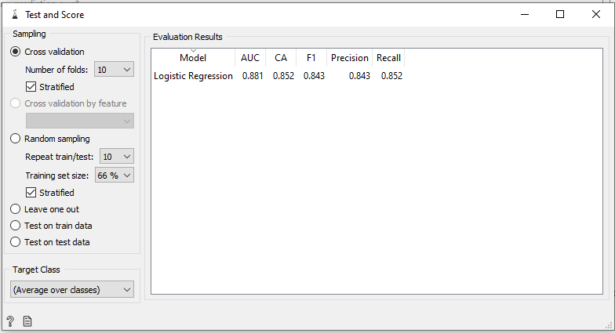

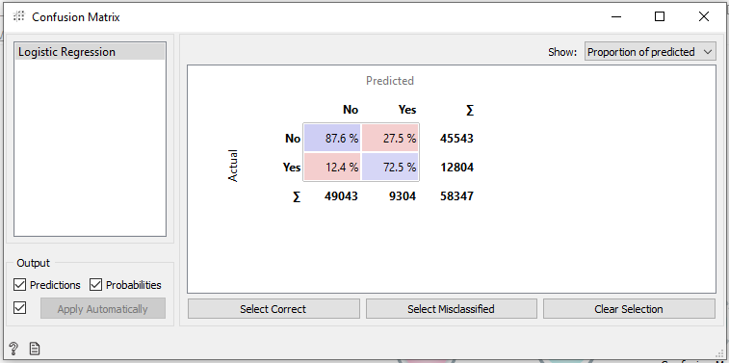

**Practical No 8**

**Aim:** Write a java program to Calculate the Alon Matias Szegedy Algorithm for given stream.

**Code:**

/*

* Click nbfs://nbhost/SystemFileSystem/Templates/Licenses/license-default.txt to change this license

* Click nbfs://nbhost/SystemFileSystem/Templates/Project/Maven2/JavaApp/src/main/java/${packagePath}/${mainClassName}.java to edit this template

*/

package com.mycompany.amsa;

import java.util.Arrays;

import java.lang.String;

public class AMSA {

public static int findCharCount(String stream, char XElement, int random, int length) {

int charCount = 0;

for(int i = random; i < length; i++)

{

if(stream.charAt(i) == XElement)

{

charCount++;

}

}

return charCount;

}

public static int estimateValue(int XValue, int length) {

int expValue = length * (2 * XValue - 1);

return expValue;

}

public static void main(String[] args) {

String stream = "abcbdacdabdcaab";

int approxSecondMoment, length = stream.length();

int[] randomValues = {3, 8, 13};

char[] XElement = new char[3];

int[] XValue = new int[3];

int[] expValue = new int[3];

for(int i = 0; i < XElement.length; i++)

{

XElement[i] = stream.charAt(randomValues[i] - 1);

XValue[i] = findCharCount(stream, XElement[i], randomValues[i] - 1, length);

expValue[i] = estimateValue(XValue[i], length);

System.out.println(XElement[i] + " : " + XValue[i]);

}

for (int i = 0; i < XElement.length; i++) {

System.out.println("Expected value for " + XElement[i] + " : " + expValue[i]);

}

approxSecondMoment = Arrays.stream(expValue).sum() / 3;

System.out.println("Approximate Second Moment value = " + approxSecondMoment);

}

}

**Output:**

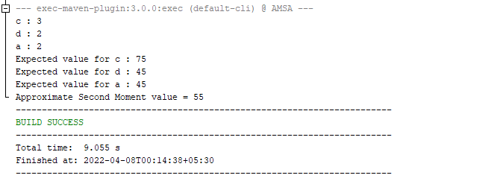

**Practical No 9**

**Aim:** Write a Program to Construct different types of K-shingles for a given document **Code:**

install.packages("tm")

require("tm")

kshingle<-function(){

k<- as.integer(readline("Enter a value for k - 1"))

u1<- readLines("C:/Users/micha/Desktop/Sem 2 Practicals/BIBD/Practical 1/inputfiles/InputFile.txt")

shingle<-i<-0

while(i<nchar(u1)-k+1)

{

shingle[i]<-substr(u1,i,i+k)

print(shingle[i])

i<-i+1

}

}

if(interactive())kshingle()

**Output:**

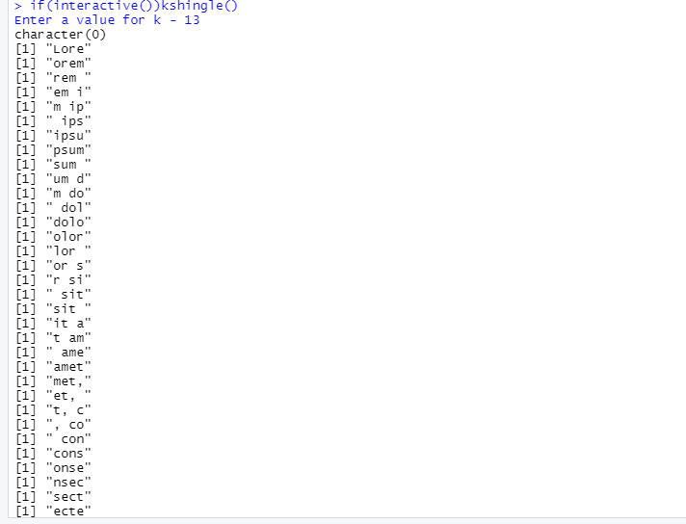

**Practical No 10**

**Aim:** Write a program for measuring similarity among documents and detecting passages which have been reused.

**Code:**

**Practical 10a**

install.packages("tm")

require("tm")

install.packages("ggplot2")

install.packages("devtools")

my.corpus<-Corpus(DirSource("C:/Users/micha/Desktop/Sem 2 Practicals/BIBD/Practical 10/Text Files"))

my.corpus<-tm_map(my.corpus,removeWords,stopwords("english"))

my.tdm<-TermDocumentMatrix(my.corpus)

#inspect(my.tdm)

my.tdm<-DocumentTermMatrix(my.corpus,control=list(weighting=weightTfIdf,stopwords=TRUE))

#inspect(my.tdm)

my.df<-as.data.frame(inspect(my.tdm))

my.df.scale<-scale(my.df)

d<-dist(my.df.scale,method="euclidean")

fit<-hclust(d,method="ward")

plot(fit)

**Output:**

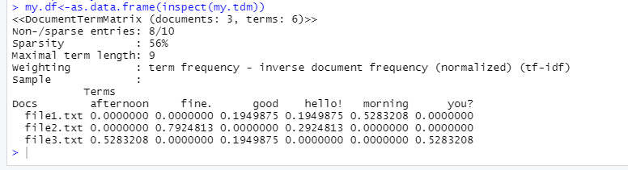

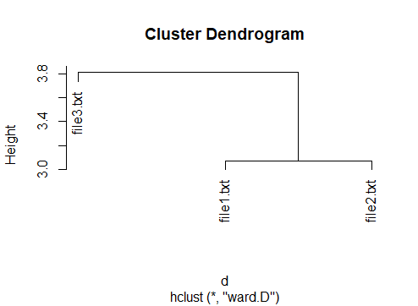

**Practical 10b**

**Code:**

install.packages("tm")

require("tm")

my.corpus <- Corpus(DirSource("C:/Users/micha/Desktop/Sem 2 Practicals/BIBD/Practical 2/Text Files"))

my.corpus <- tm_map(my.corpus, removeWords, stopwords("english"))

my.tdm <- TermDocumentMatrix(my.corpus)

inspect(my.tdm)

my.df <- as.data.frame(inspect(my.tdm))

barplot(as.matrix(my.tdm))

barplot(as.matrix(my.tdm), col = c("#00eb07", "#57ef87", "#ed791a", "#5e5fff", "#1cf1c6", "#5e035b"))

**Output:**

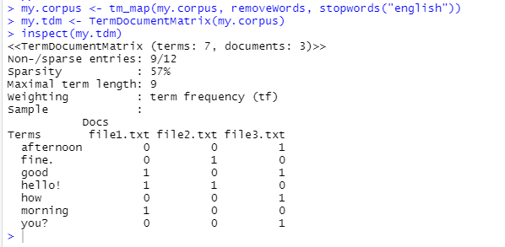

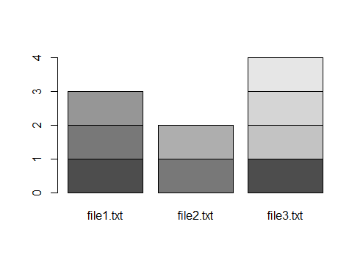

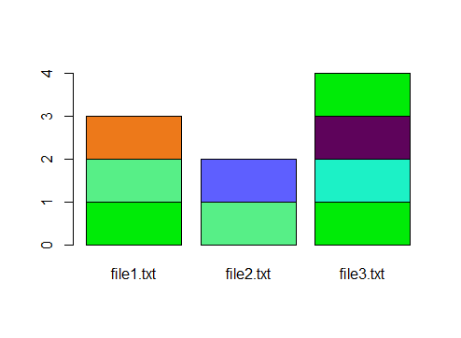

**Practical 10c**

**Code:**

install.packages("textreuse")

library("textreuse")

minhash <- minhash_generator(200, seed = 235)

ats <- TextReuseCorpus(dir = "C:/Users/micha/Desktop/Sem 2 Practicals/BIBD/Practical 2/Text Files 2c", tokenizer = tokenize_ngrams, n = 5, minhash_func = minhash)

buckets <- lsh(ats, bands = 50, progress = interactive())

candidates <- lsh_candidates(buckets)

scores <- lsh_compare(candidates, ats, jaccard_similarity, progress = F)

scores

barplot(as.matrix(scores), col = c("#00eb07", "#57ef87", "#ed791a", "#5e5fff", "#1cf1c6", "#5e035b"))

**Output:**

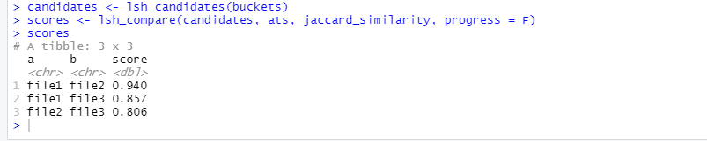

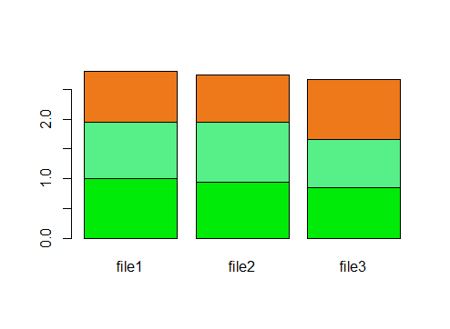

**Practical No 11**

**Aim:** Write a java Program to demonstrate the k-moments for zeroth, first and second moments.

**Code:**

package com.mycompany.kmoments;

import java.io.*;

import java.util.*;

public class Kmoments {

public static void main(String[] args) {

int n = 15;

String stream[] = {"a","b","c","b","d","a","c","d","a","b","d","c","a","a","b"};

int zerothMoment = 0, firstMoment = 0, secondMoment = 0, count = 1, flag = 0;

ArrayList<Integer> arrayList = new ArrayList();

for(String character : stream){

System.out.print(character + "\t\t\t");

}

System.out.println();

Arrays.sort(stream);

for(int i = 1; i < n; i++)

{

if(stream[i] == stream[i - 1]){

count++;

}

else

{

arrayList.add(count);

count = 1;

}

}

arrayList.add(count);

System.out.println("Zeroth moment:\t\t\t" + zerothMoment);

for(int i : arrayList){

firstMoment += i;

secondMoment += i * i;

}

System.out.println("First Moment:\t\t\t" + firstMoment);

System.out.println("Second Moment:\t\t\t" + secondMoment);

}

}

**Output:**

